# 004. Part-1-Create Fiori KPI Tile configure on LaunchPad

KPI Tiles /Analytical Tiles:

1. Create KPI drill down report.
2. Create KPI tile.
3. Add drill down report to the KPI tile.
4. Add Fiori KPI tile to the FIORI Launchpad

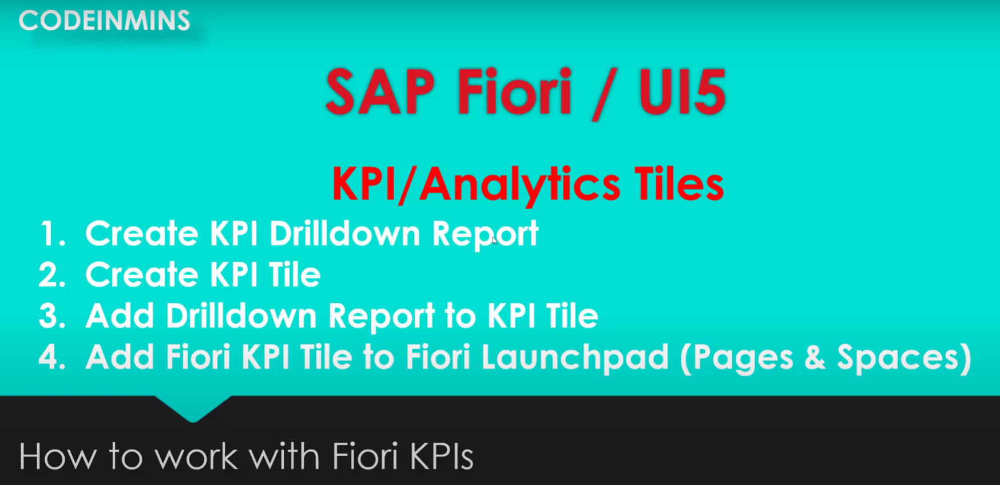

Pre-Requisites

1. Required role :SAP_BR_ANALYTICS_SPECIALIST: is used to activate the tile, which we are going to use.
2. Transaction Access:

/UI2/SEMOBJ: to create the sematic object

PFCG: adding role to the user.

/UI2/FLPD_CUST:

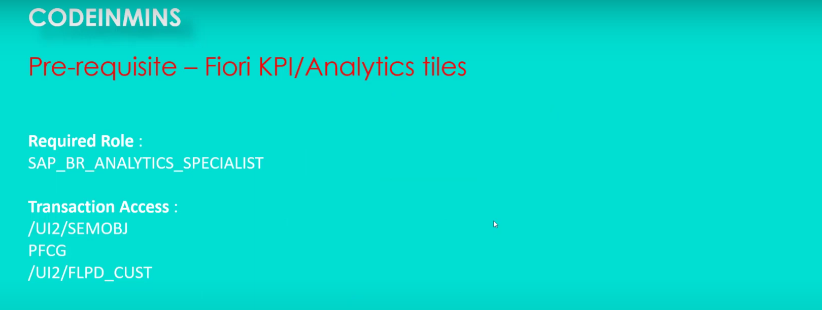

KPI used for to present quick and easy to access the numbers or information about business.

KPI- Key Performer Indicator Tiles

KPI tile types:

1. NUMERIC Tiles
2. COMPARISON Tiles
3. Trending Tiles
4. COMPARISON Tiles(Multi Purposes)
5. Dual Tiles.

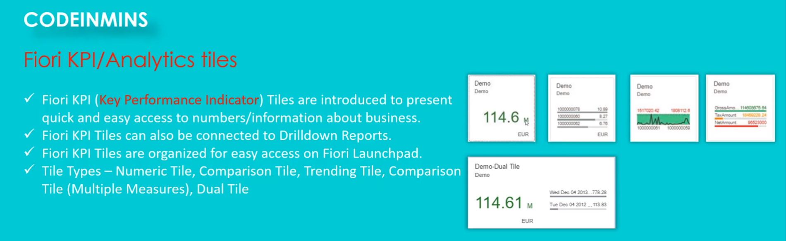

We will use the spaces and pages concepts to test this tile to the Fiori launchpad.

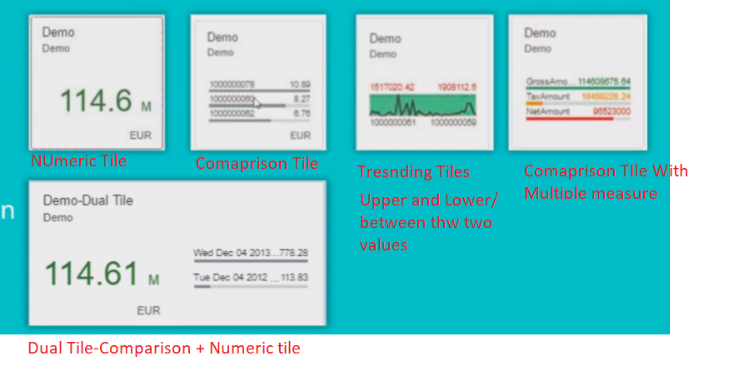

To create a drill down report, firs we need to gateway service , which will responsible to return the data.

We want show on our drill down report.

Interface View:

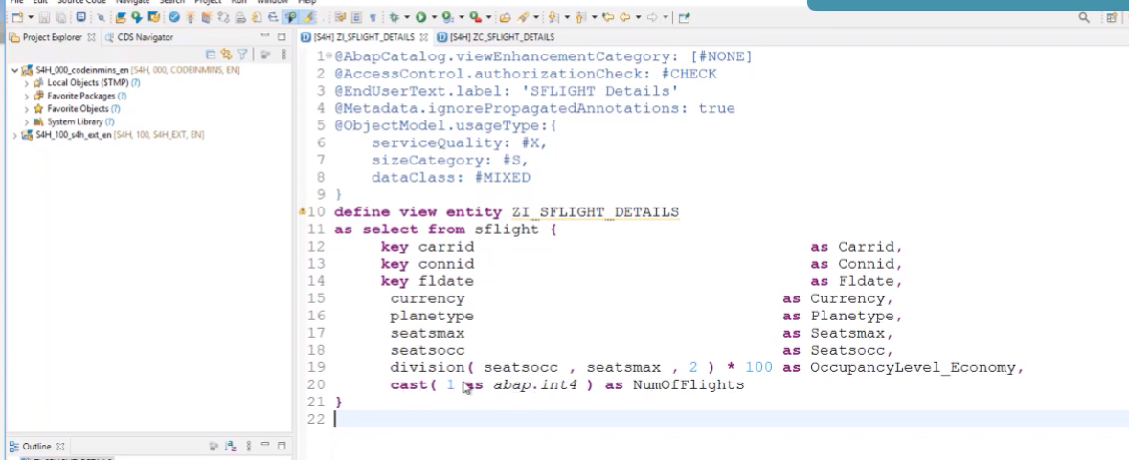

Consumption View of Interface View:

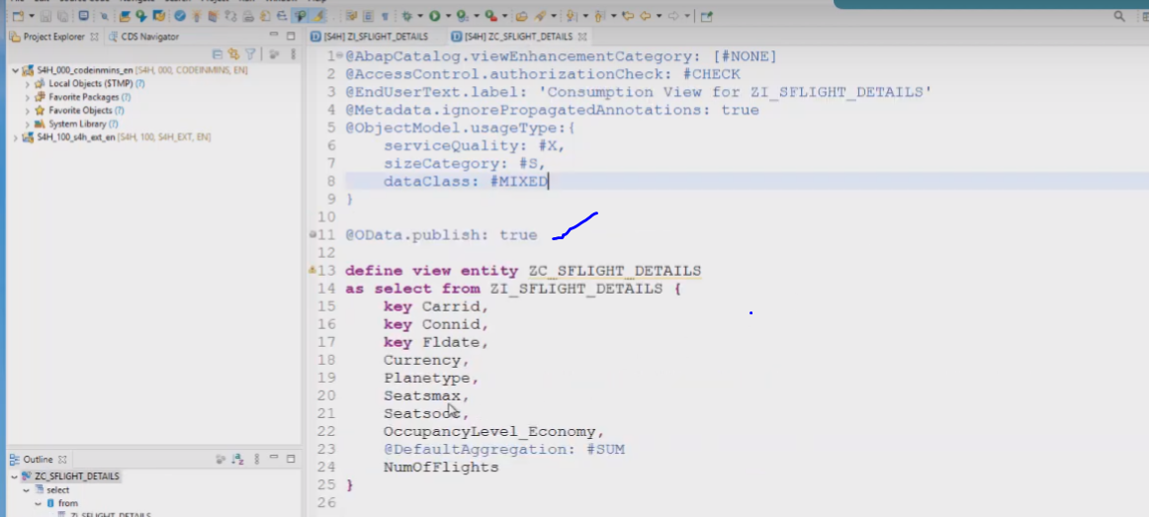

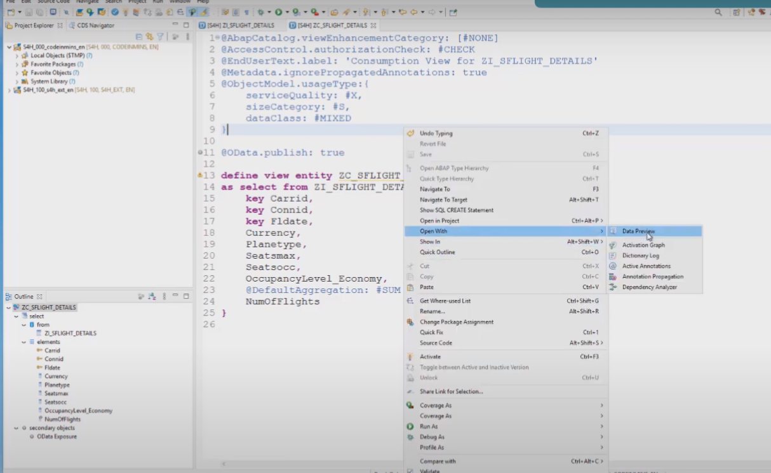

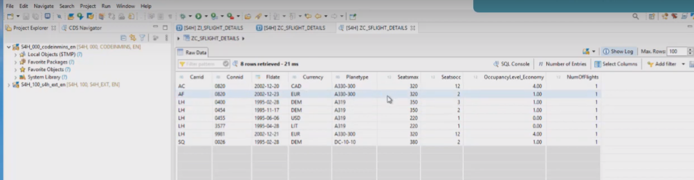

Already published the CDS View: ZC_SFLIGHT_DETAILS in Odata Service.

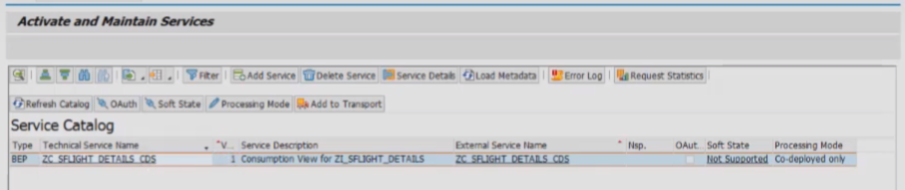 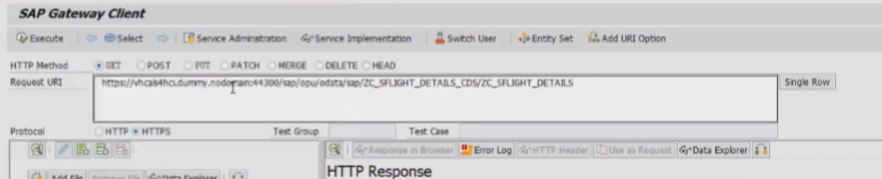

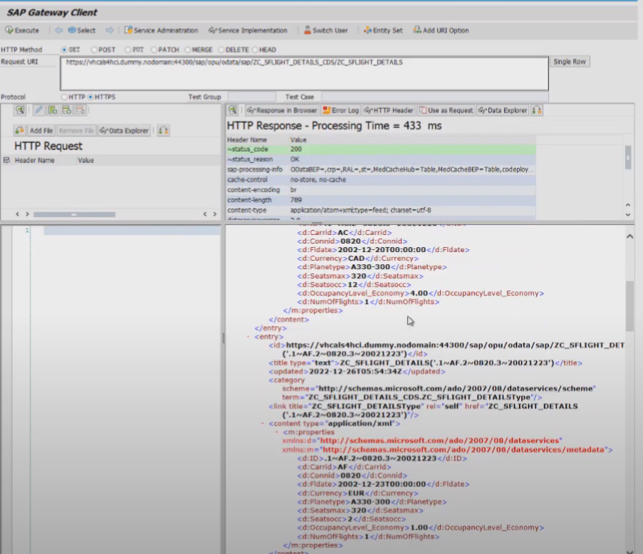

Output: you will get all of the flights available in the system.

## Now open the FLPD and start the drill down report for KPI tile.

Now we are in the Fiori Launchpad for KPI tile.

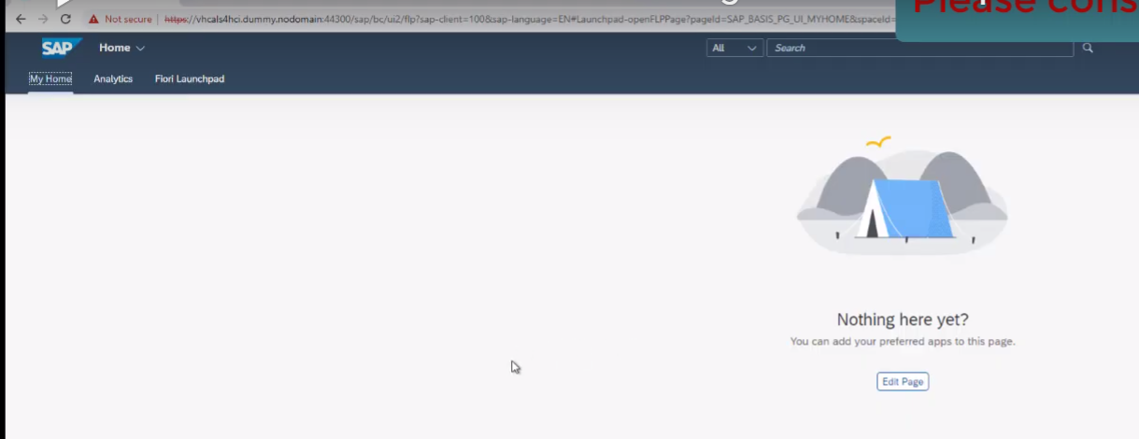

We have got the analytics tab here and it shows the KPI design and to get this tile (mange KPI and Reports) adding with pre-requisites

We are seeing the KPI design in Fiori Launchpad and We are able to see the tile - “Manage KPIs and Reports”.

Now we have got the analytics tab here and which shows the KPI design

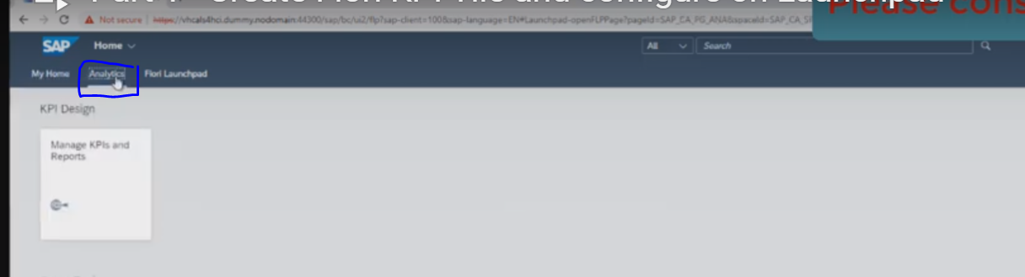

To create the reports: lets click on the tile -Mange KPIs and Reports

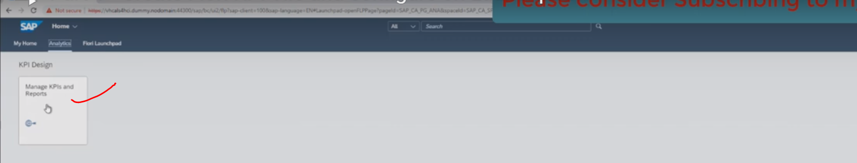

Next screen appears:

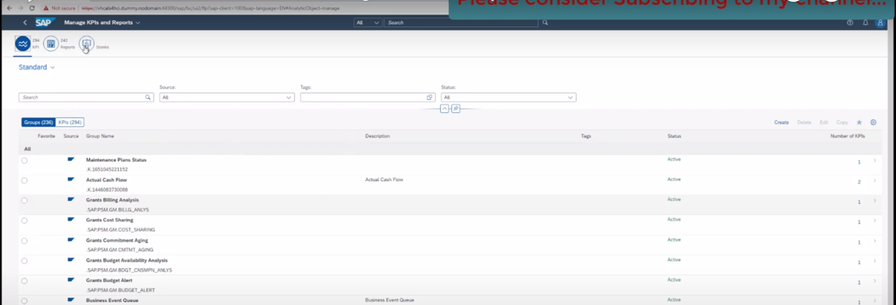

Next need to create the group, group means – collect all of the KPI tiles at one location./collection of different KPIs.

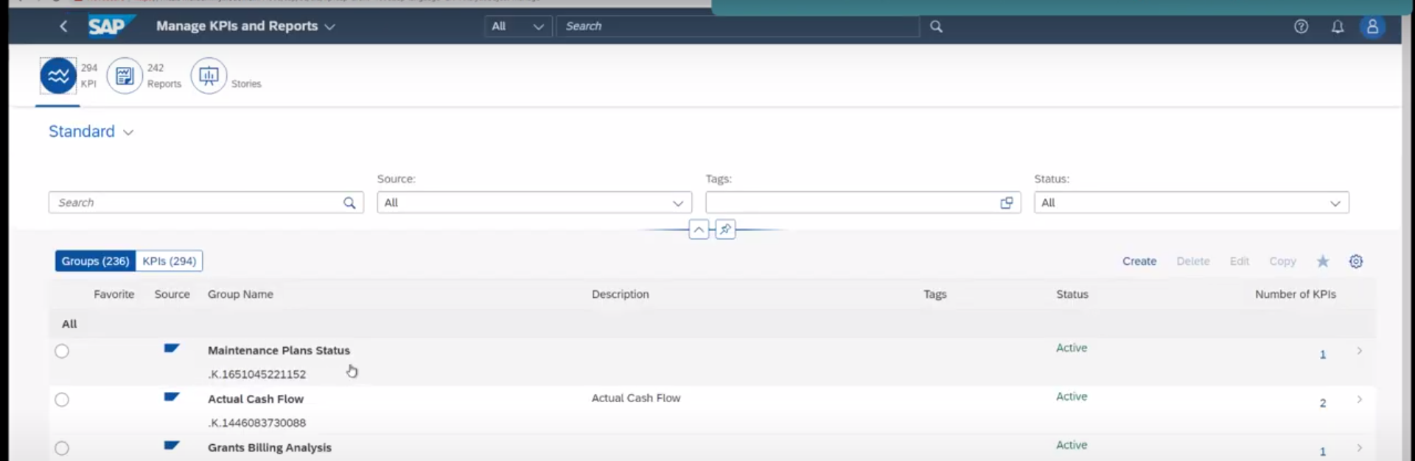

To create New group: click on create button.

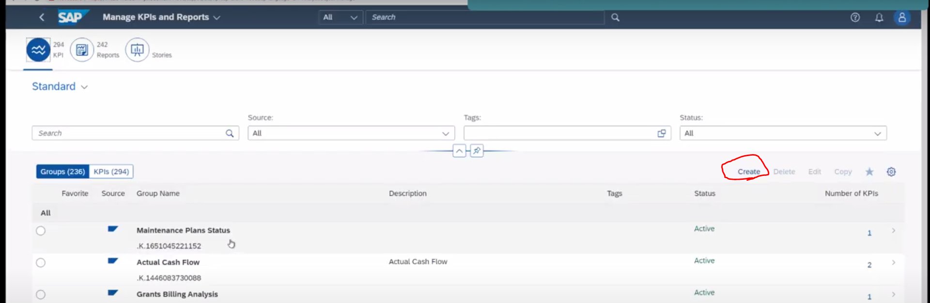

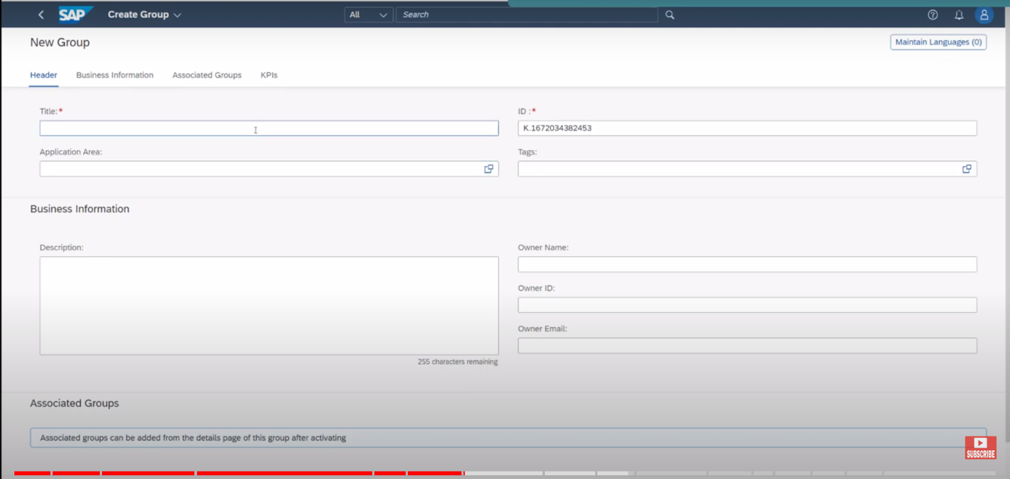

Header tab:

Provide title : remain ui elements all are optional. 🡪 I am not going to add.

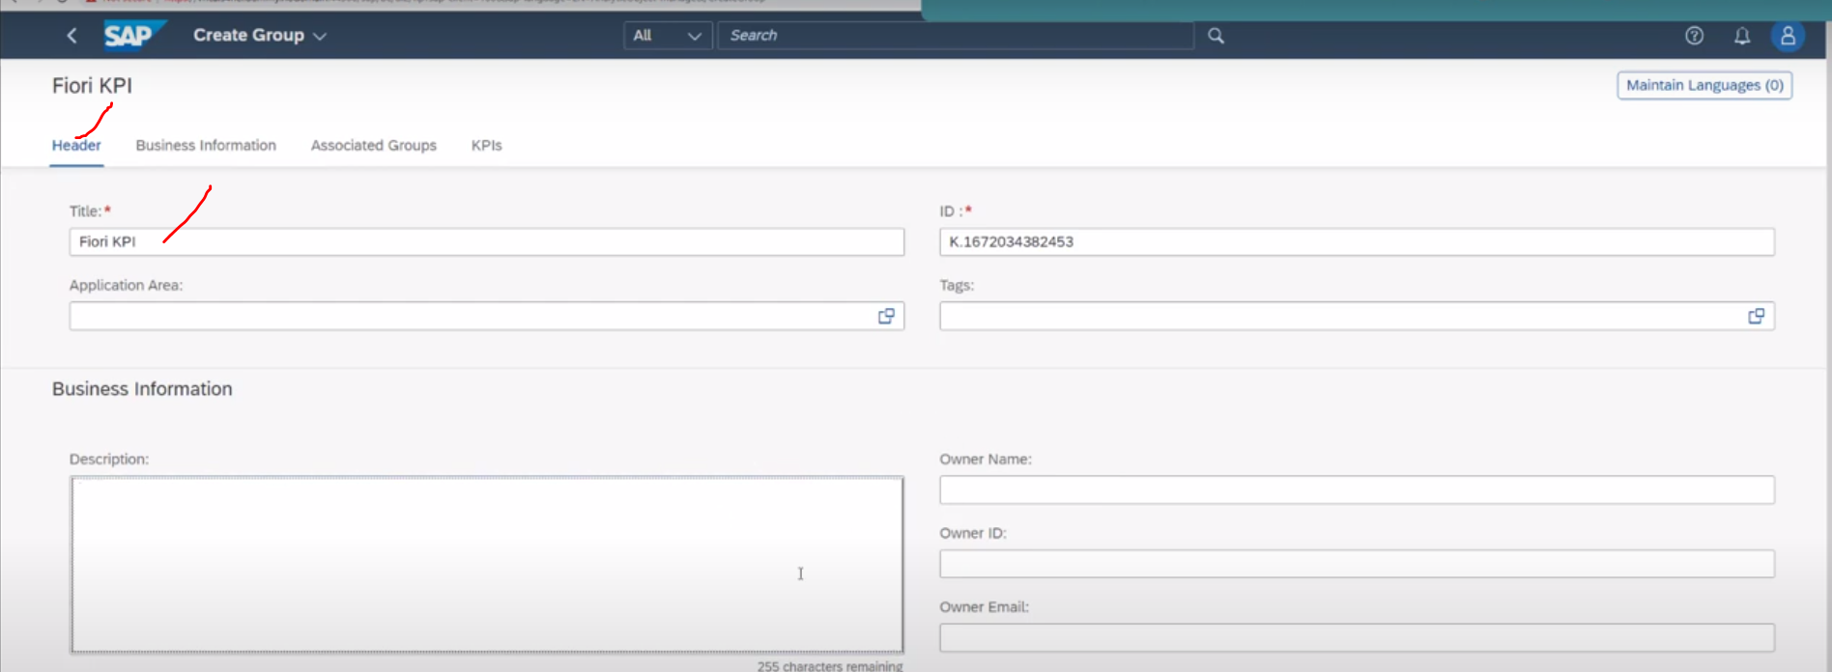

Now click on save and active.

Save it in local or in TR.

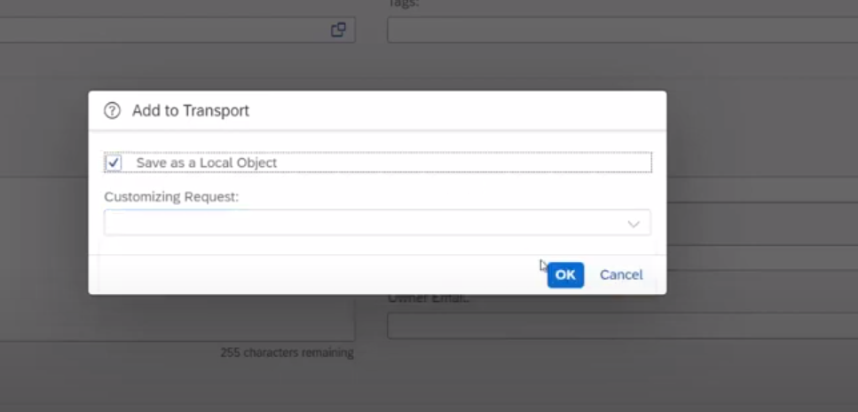

Click on OK – Now my group is activated-Fiori KPI.

Now I don’t have any KPI currently 🡪 create the KPIs

Go to : Business Information tab: and KPIs Box.—click on ADD button.

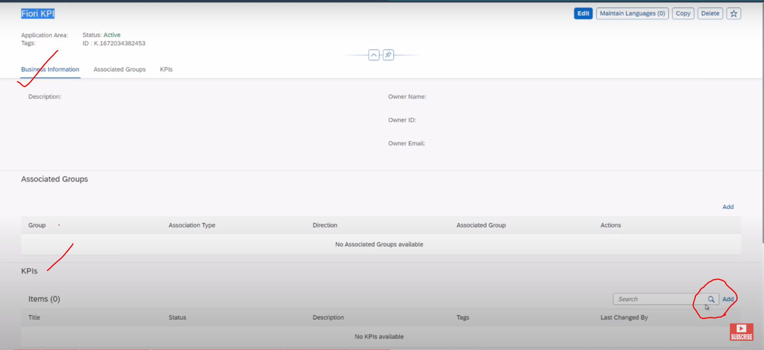

Now New KPIs screen will appears☹Create KPIs:

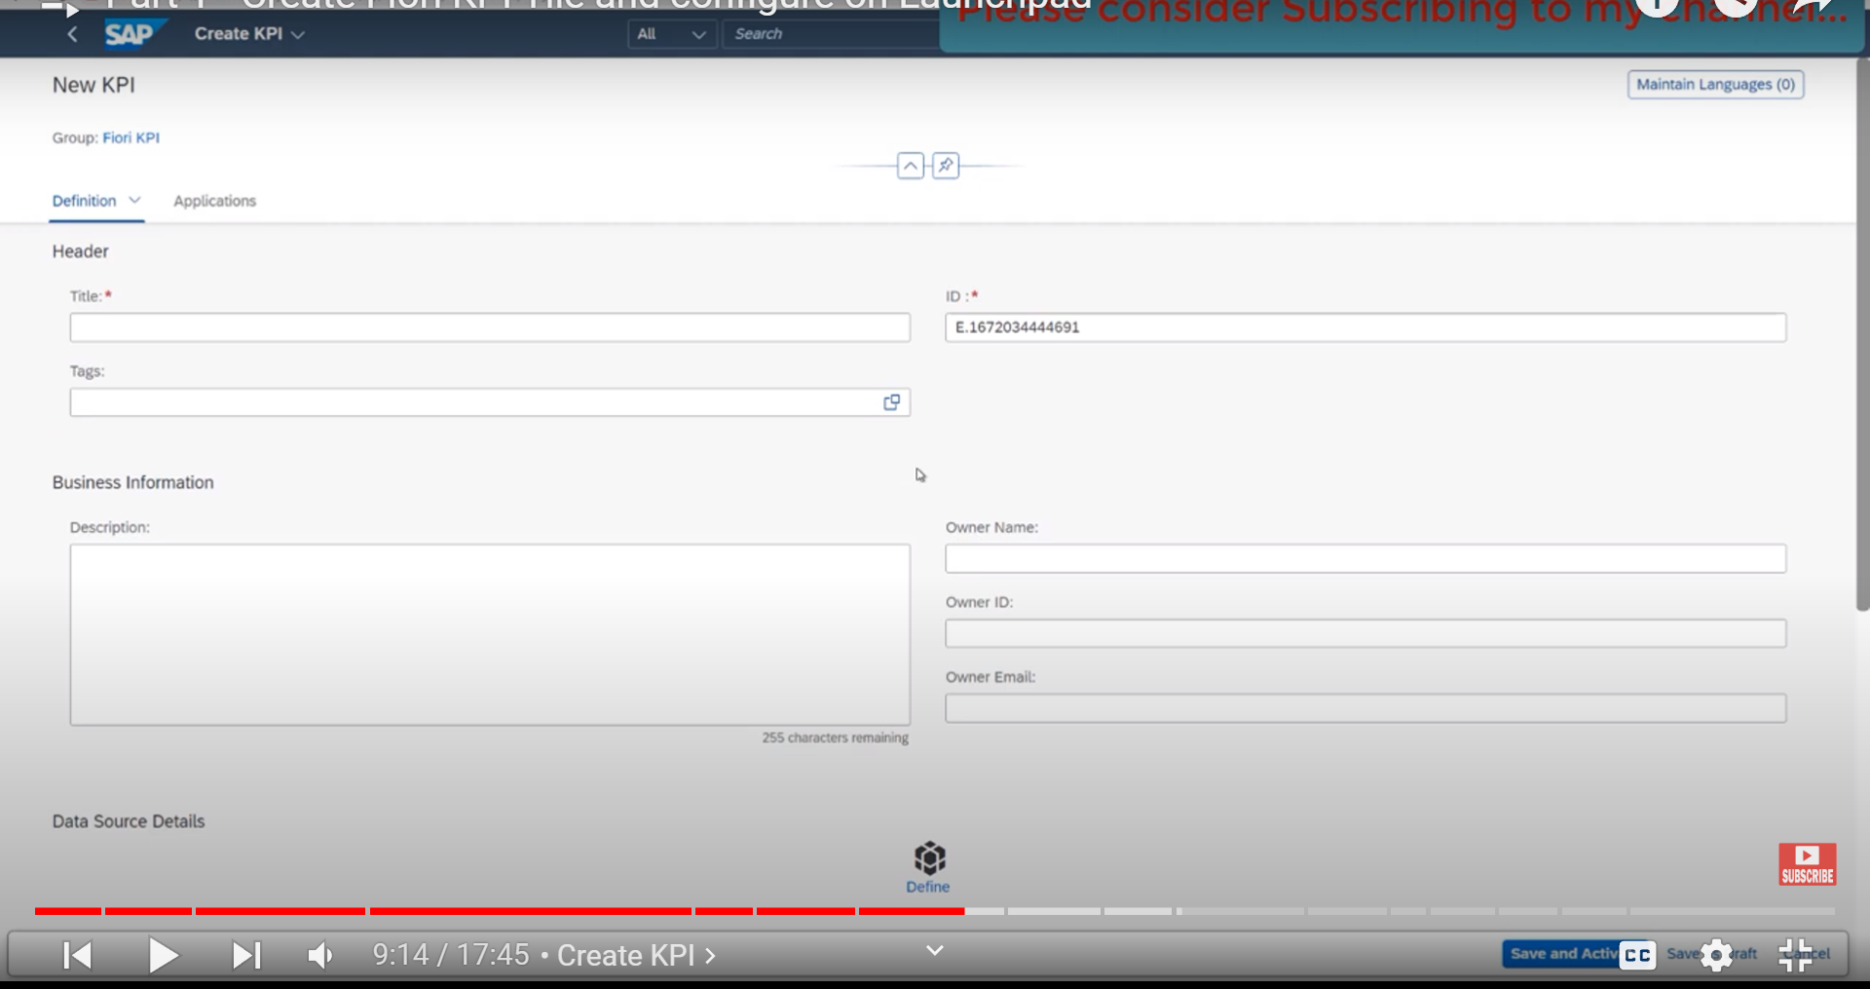

Provide Title: and Source name : means from where data would be coming.



Title :Flight details

And go to data source details section:

Click on define button

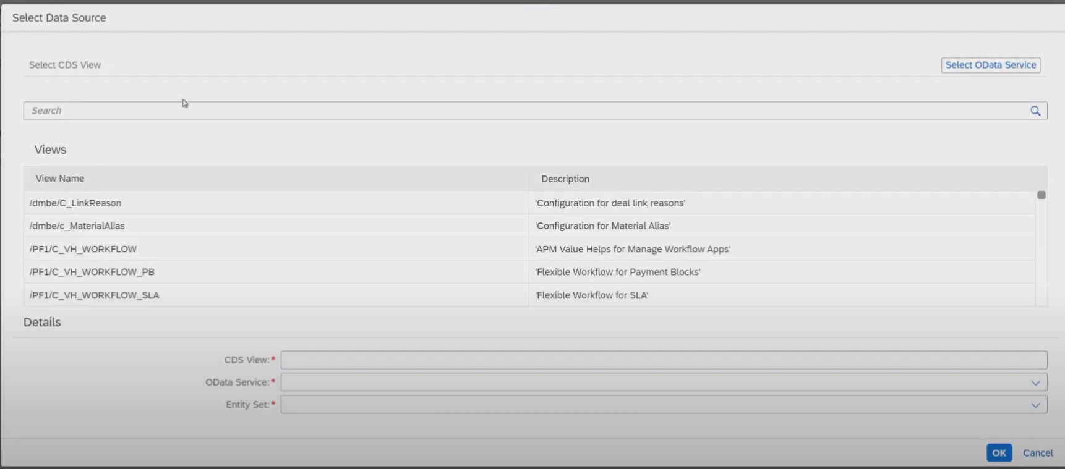

Data Source: Here we have 2 -Options:

1. CDS view
2. Odata service

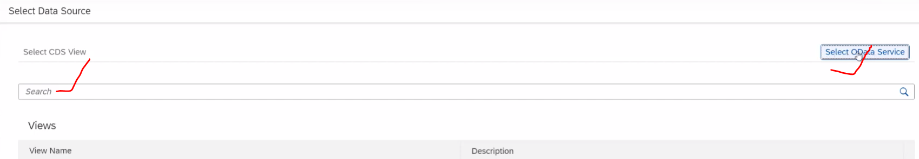

Chosen the CDS View : Name: ZC_SFLIGHT_DETAILS

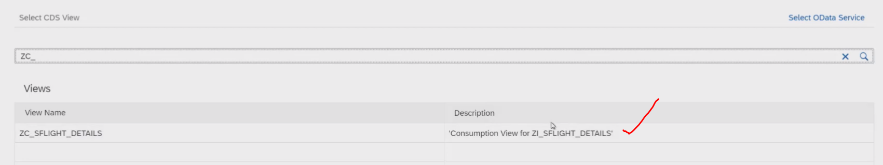

Select this :

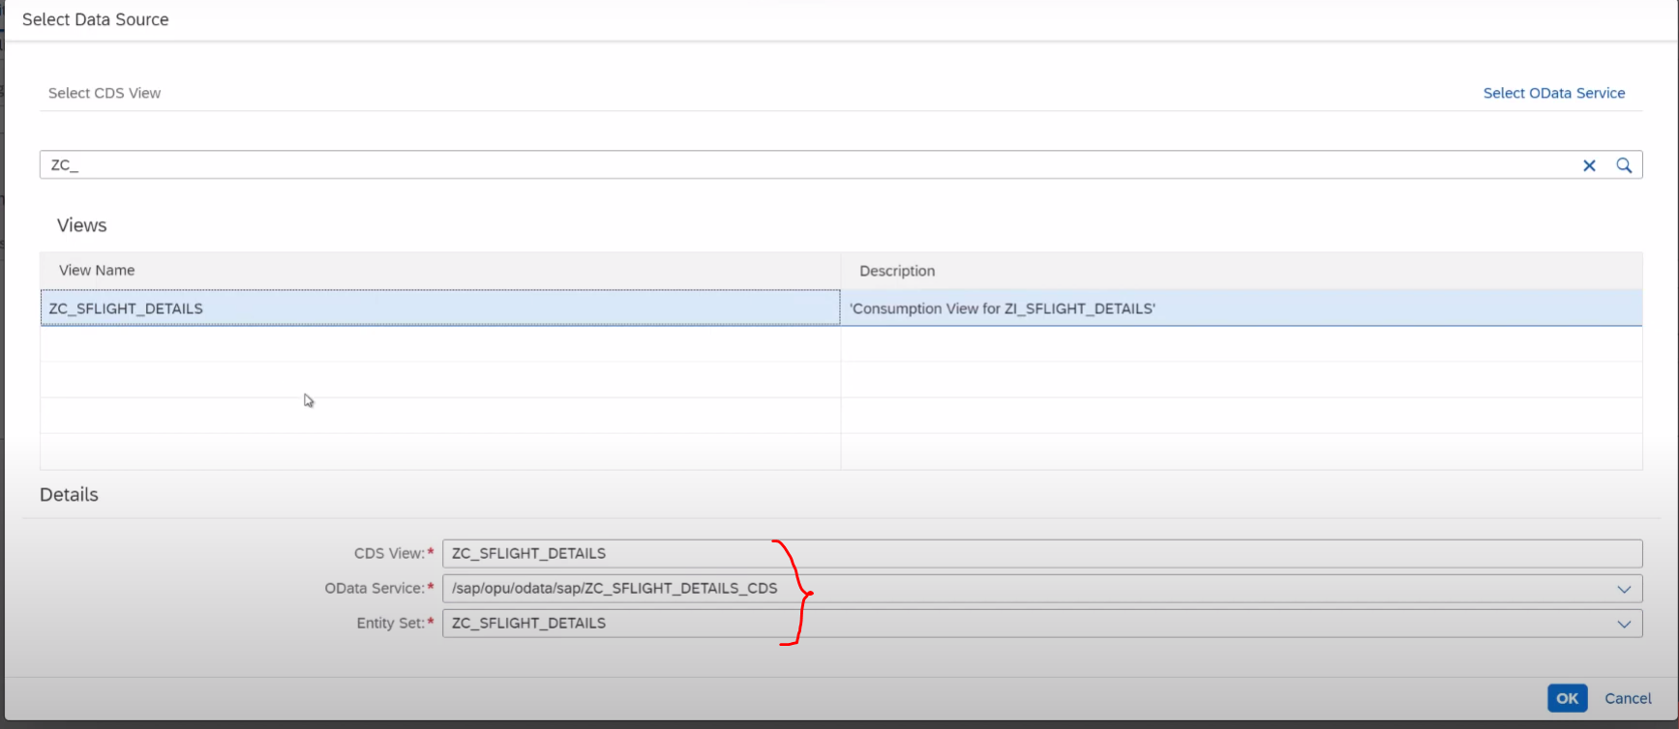

Click on OK.

Now data source details appears inside the Business information tab:

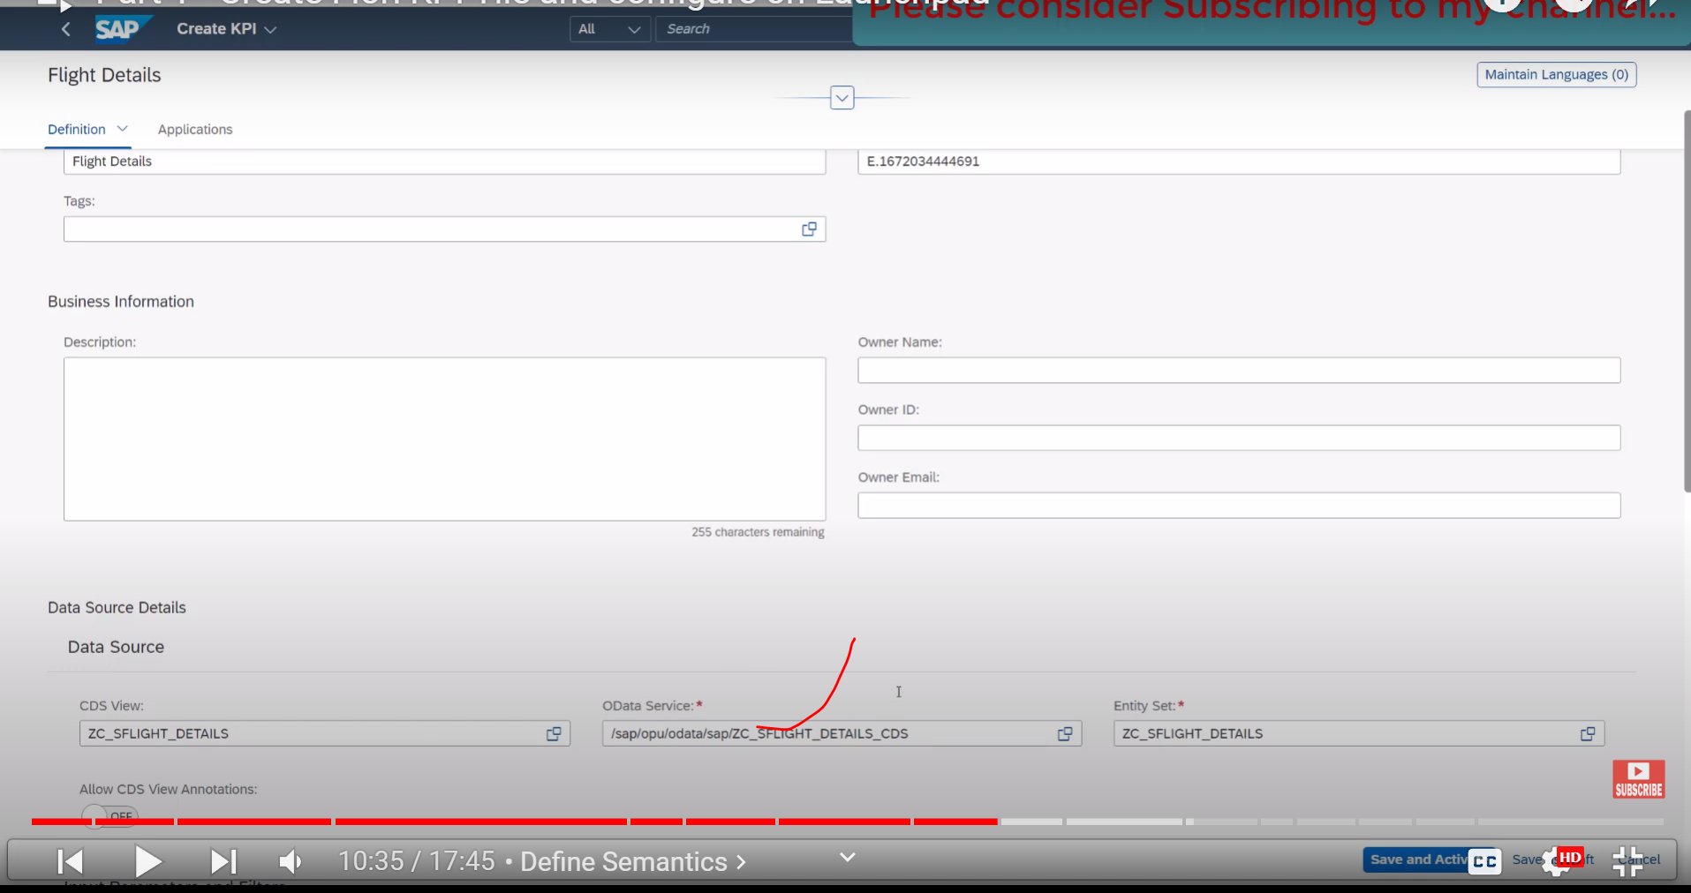

In Business Information tab: Next Semantics Section

Semantics: How data should be display on report.

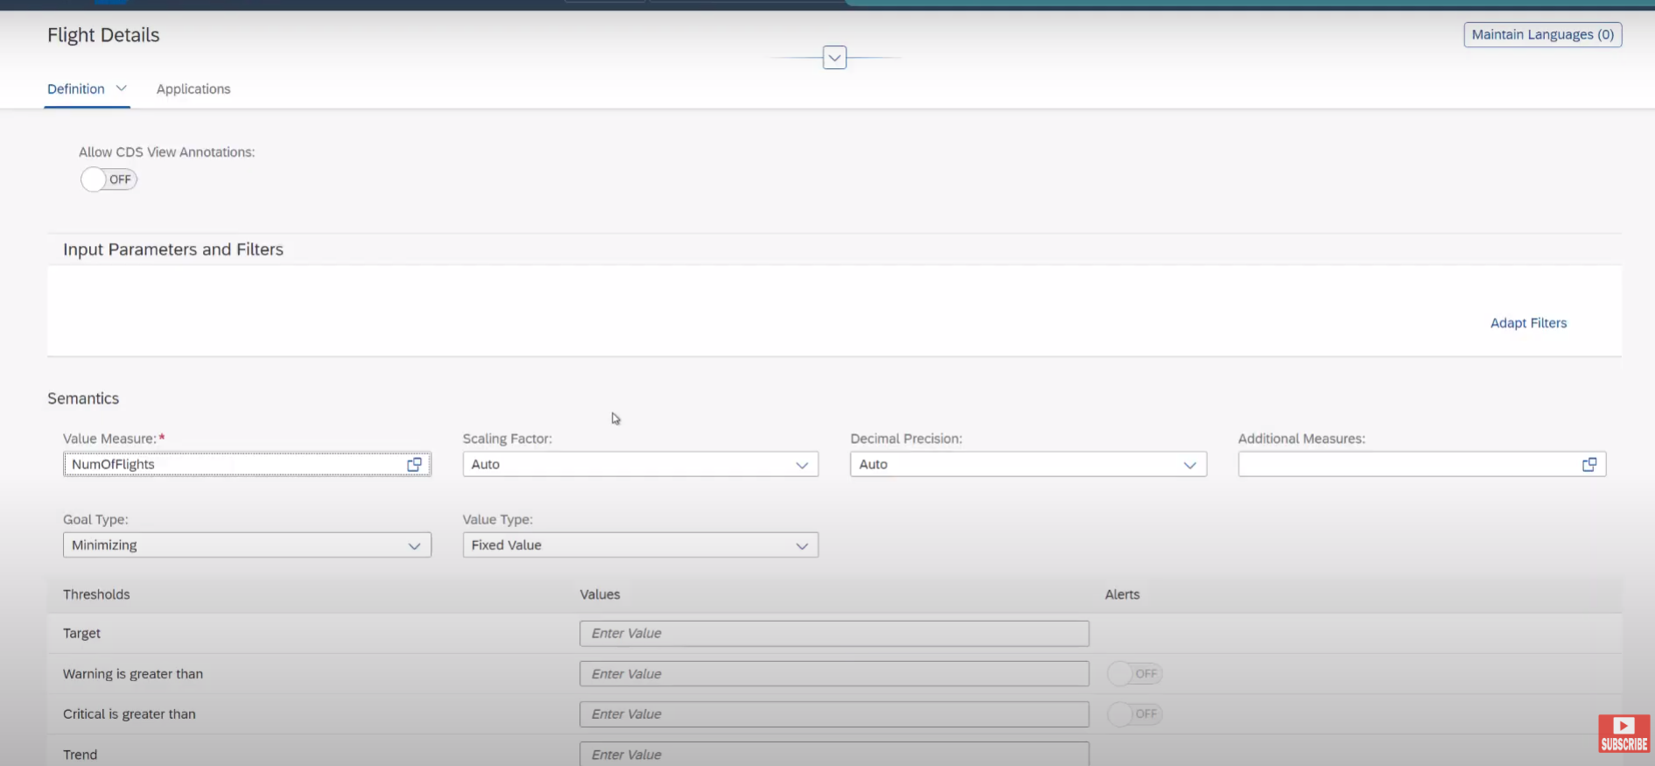

Value: NumOfFlights

Goal Type: Maximum

Thresholds: KPI Numbers display on different colors

Critical less than – value 🡨 red color

Warning is lesserthan – value 🡨 Orange color

Target Value : Green Color

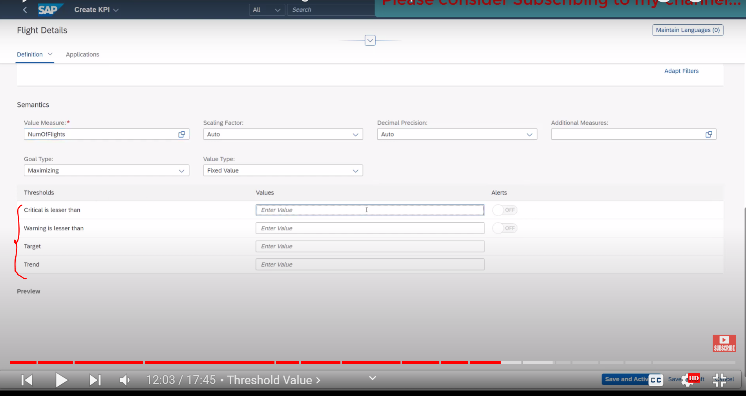

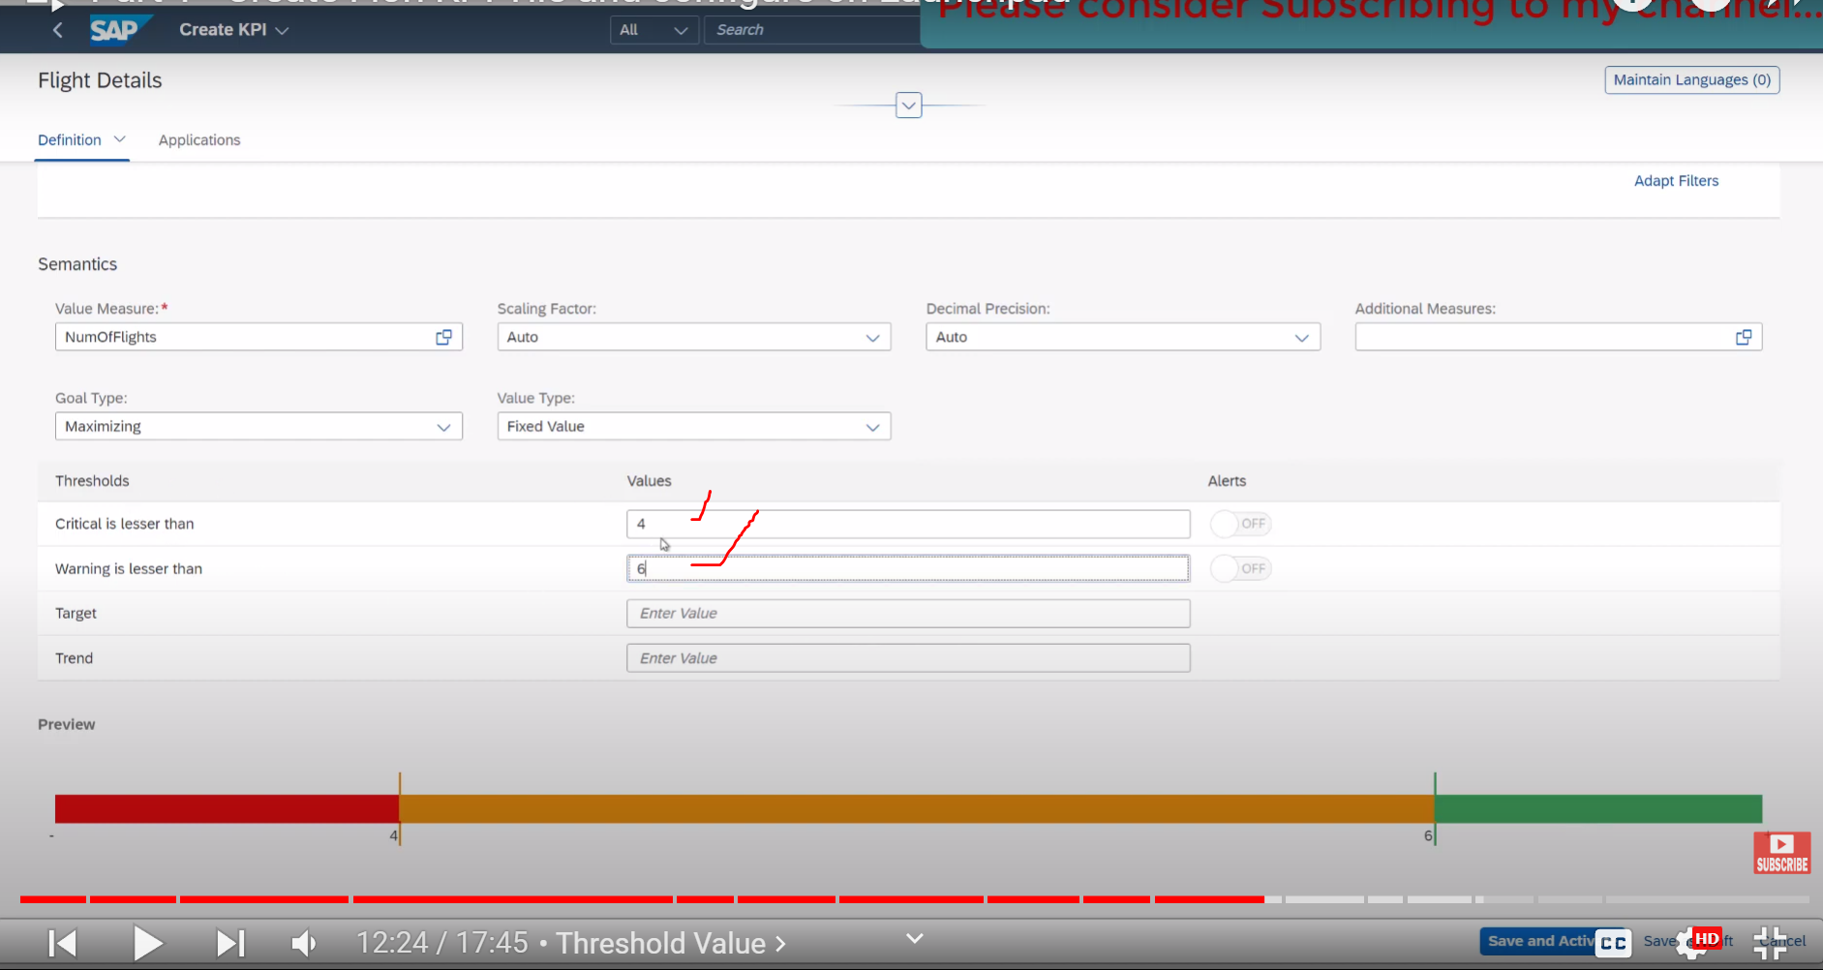

Save and activate:

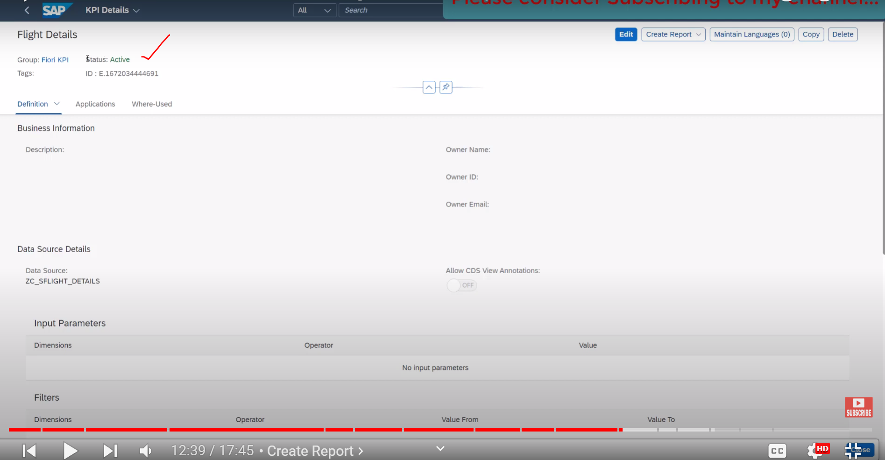

Now KPI is active

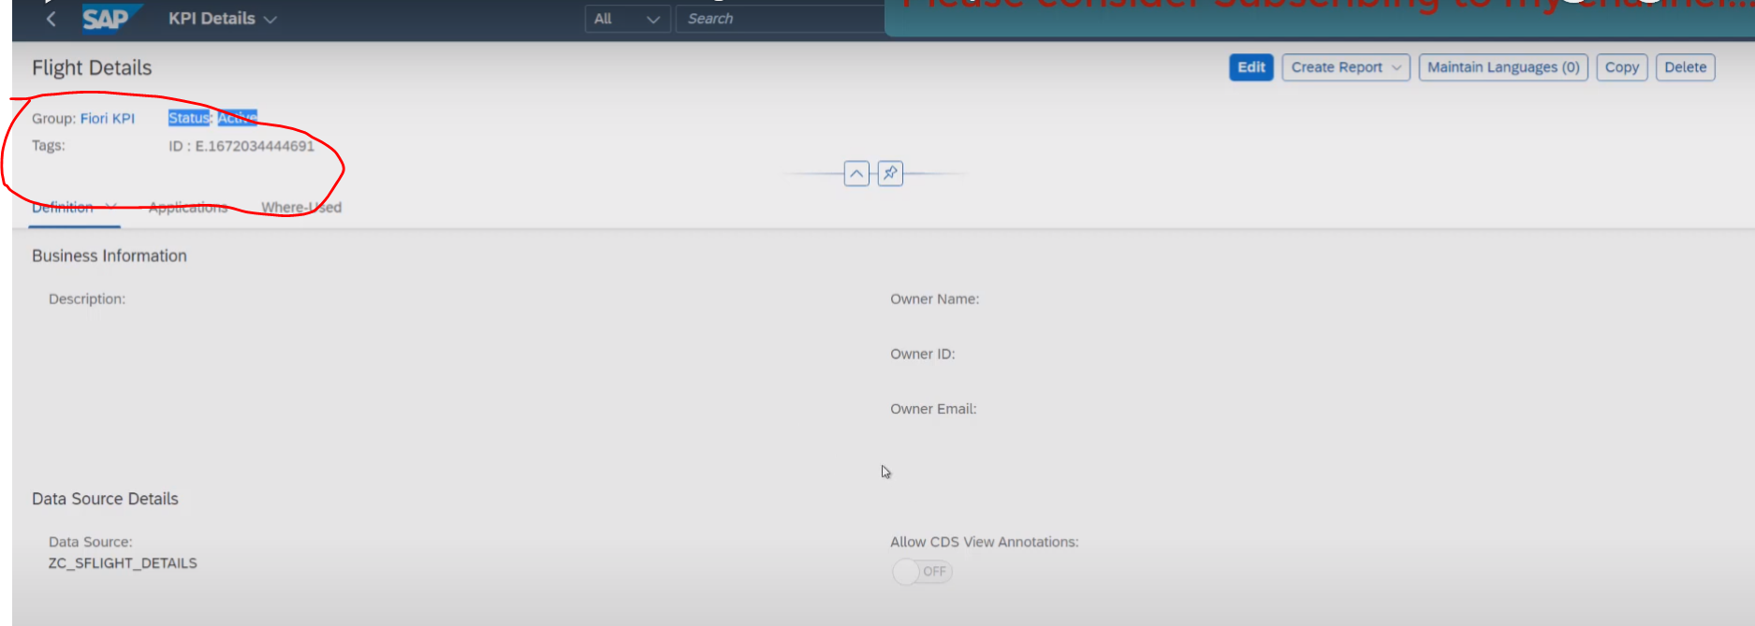

We have created the Group and inside the group , we have added the KPIs

Now we need to create the reports to display the details.

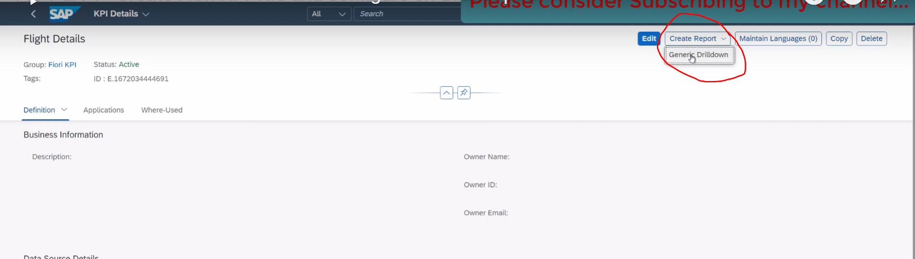

Once click on Generic Report:

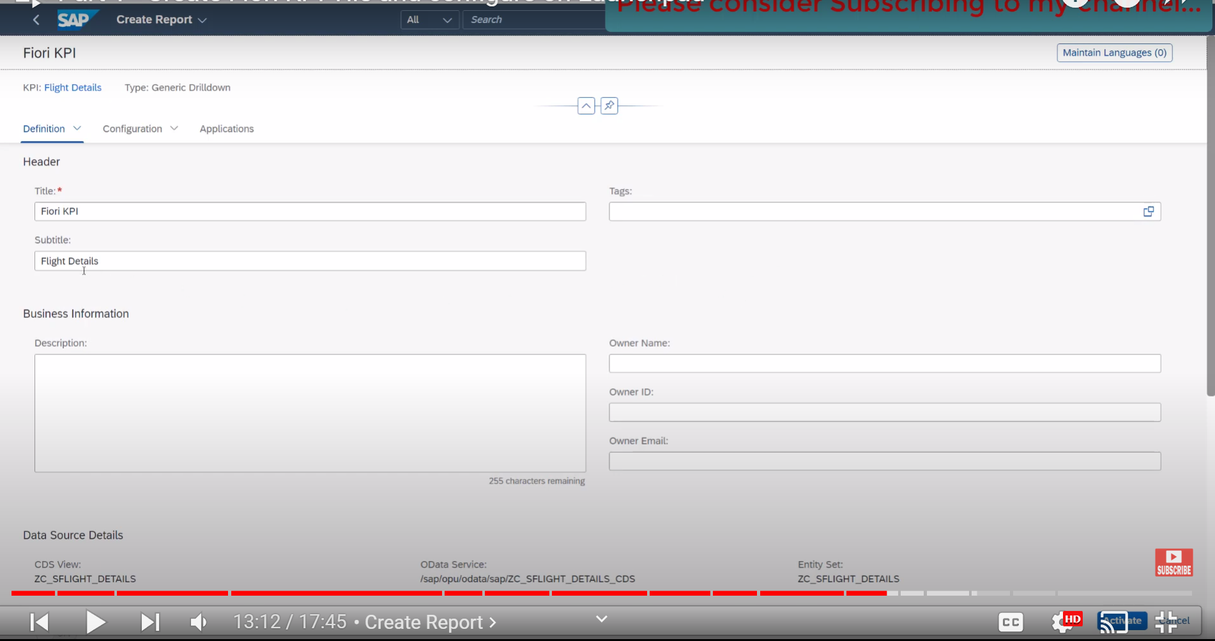

Definition Section: Header and Sub title(Data Source) already appears:

Go to Configuration tab : different options available, but we are concentrating on Charts and Tables.

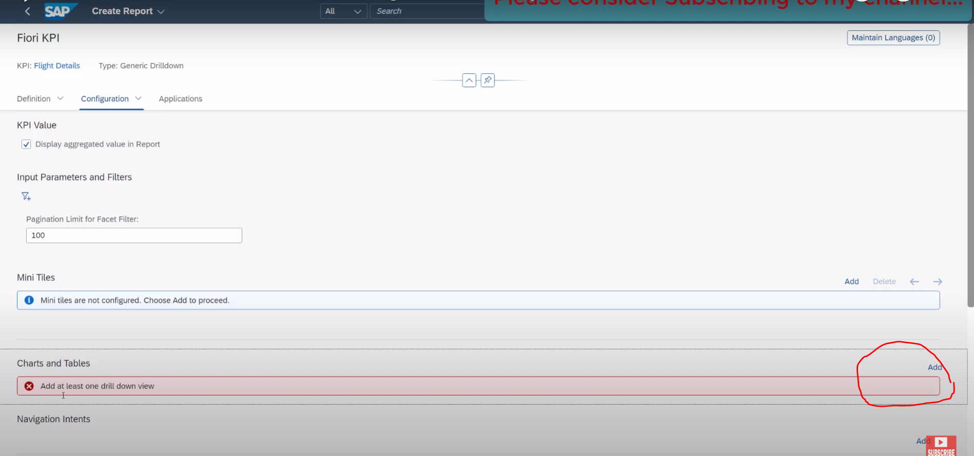

Click on ADD button

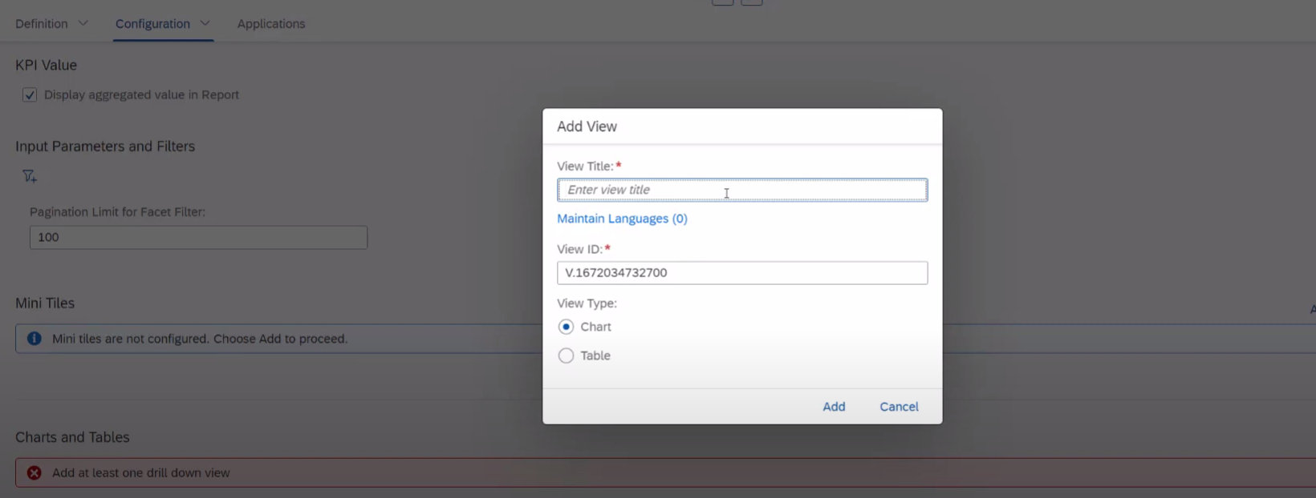

Provide View Title: Flight details:

Chart : chart + table ( both are available )

Table : only for table.

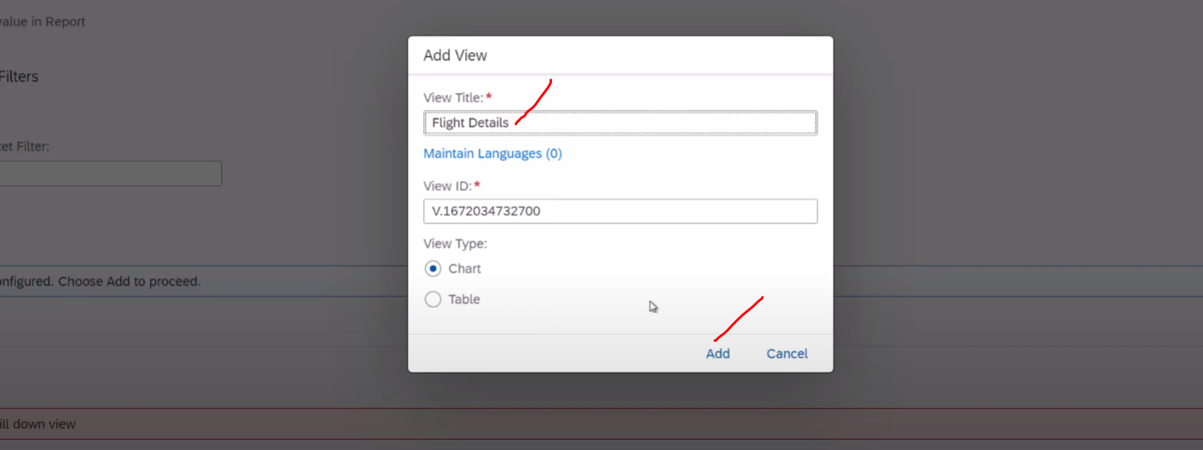

Click on ADD

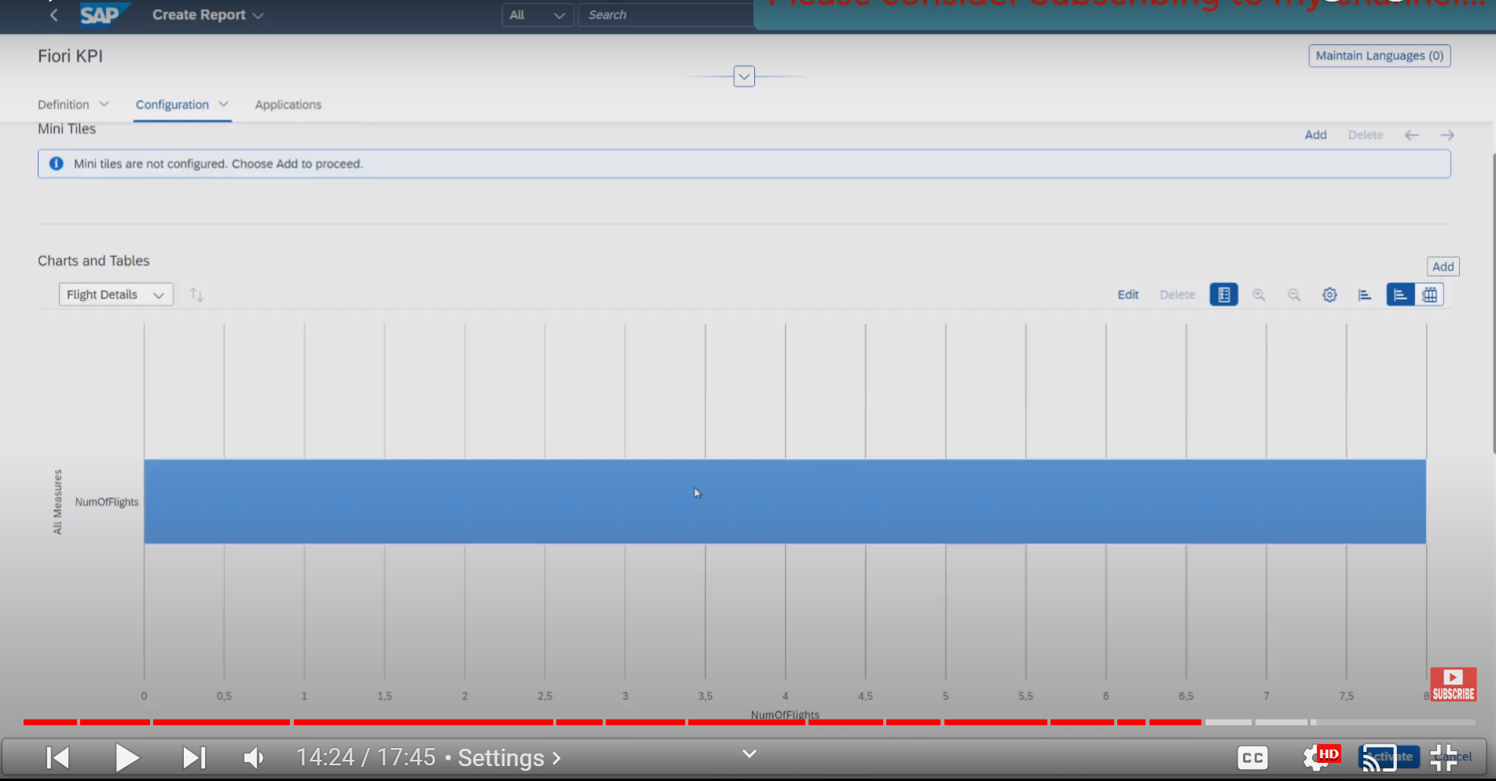

Now chart is available here , but it is not showing the details.

Lets click on settings

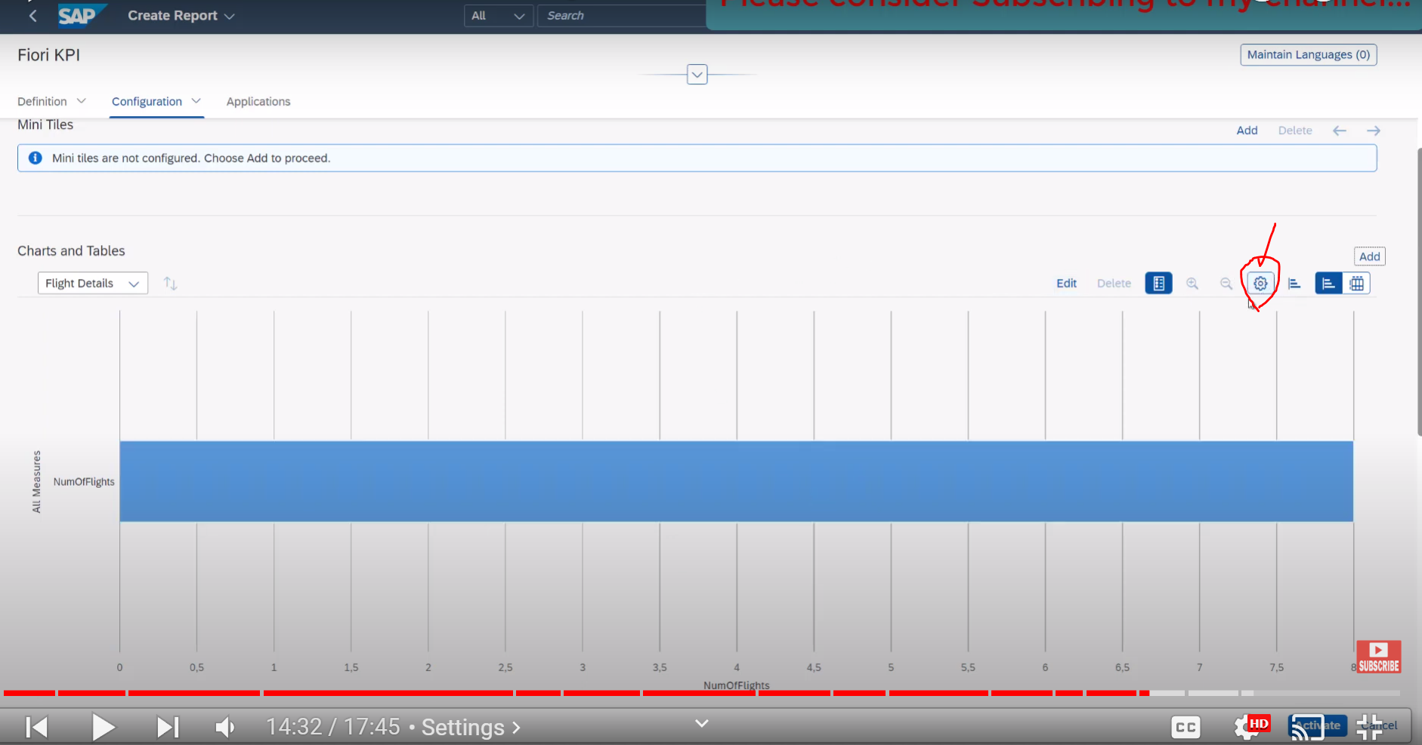

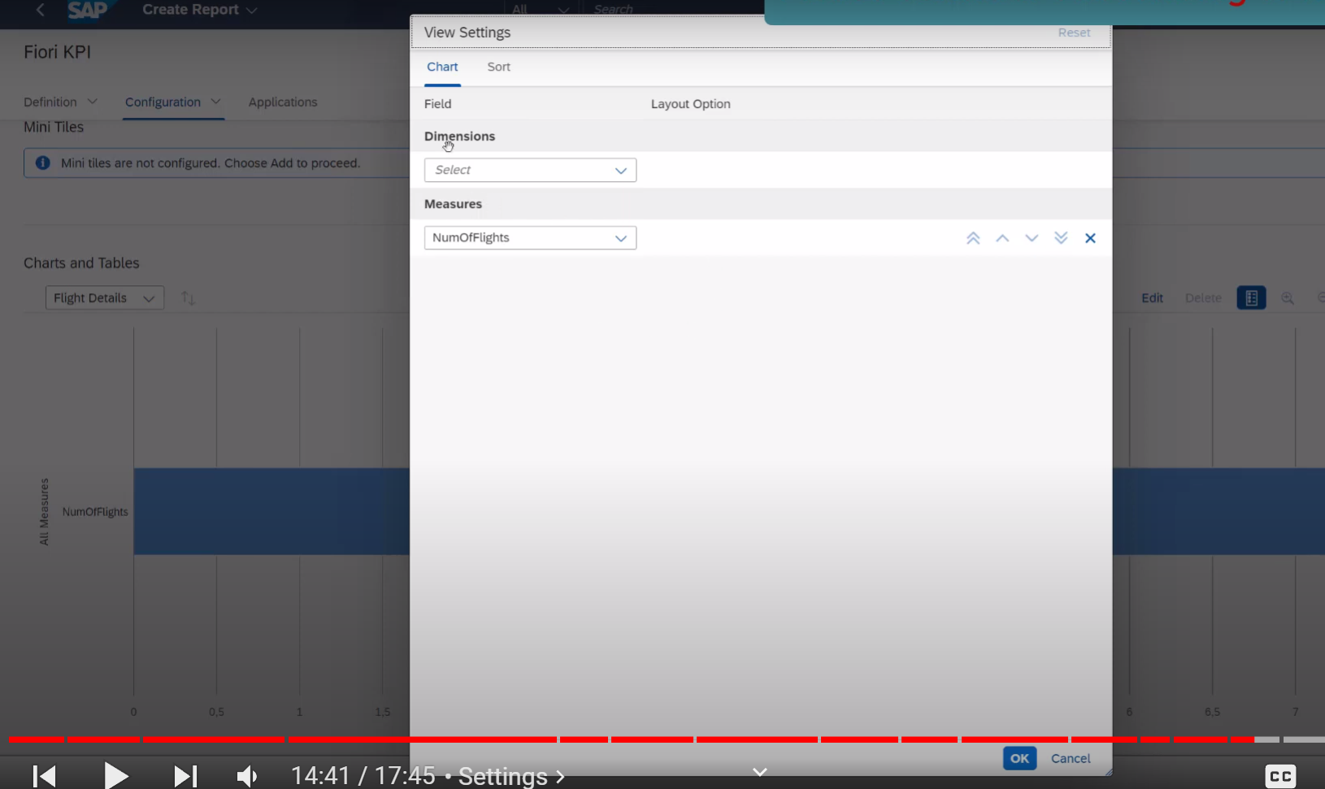

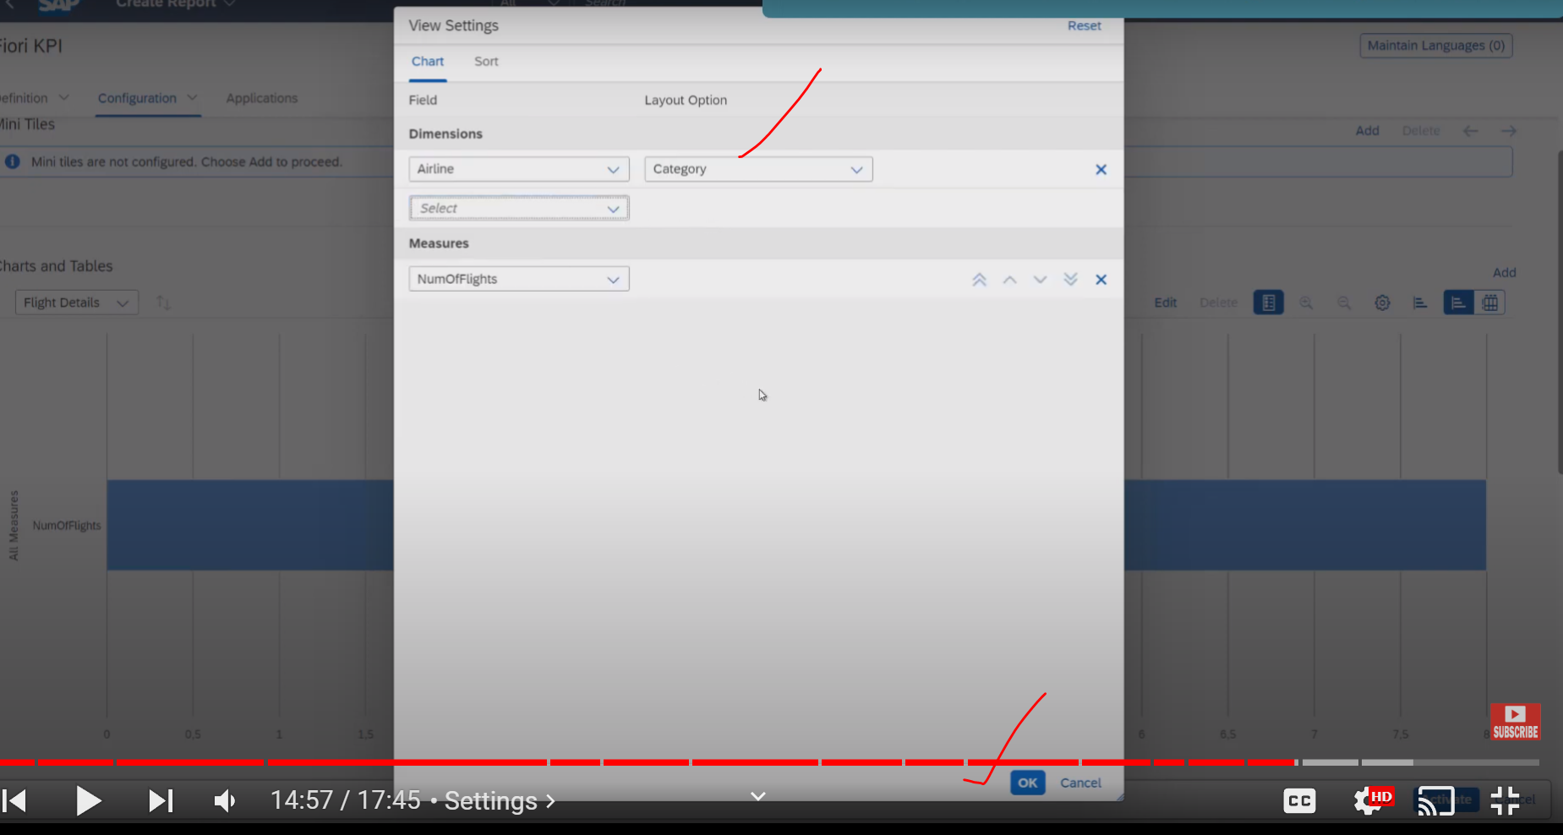

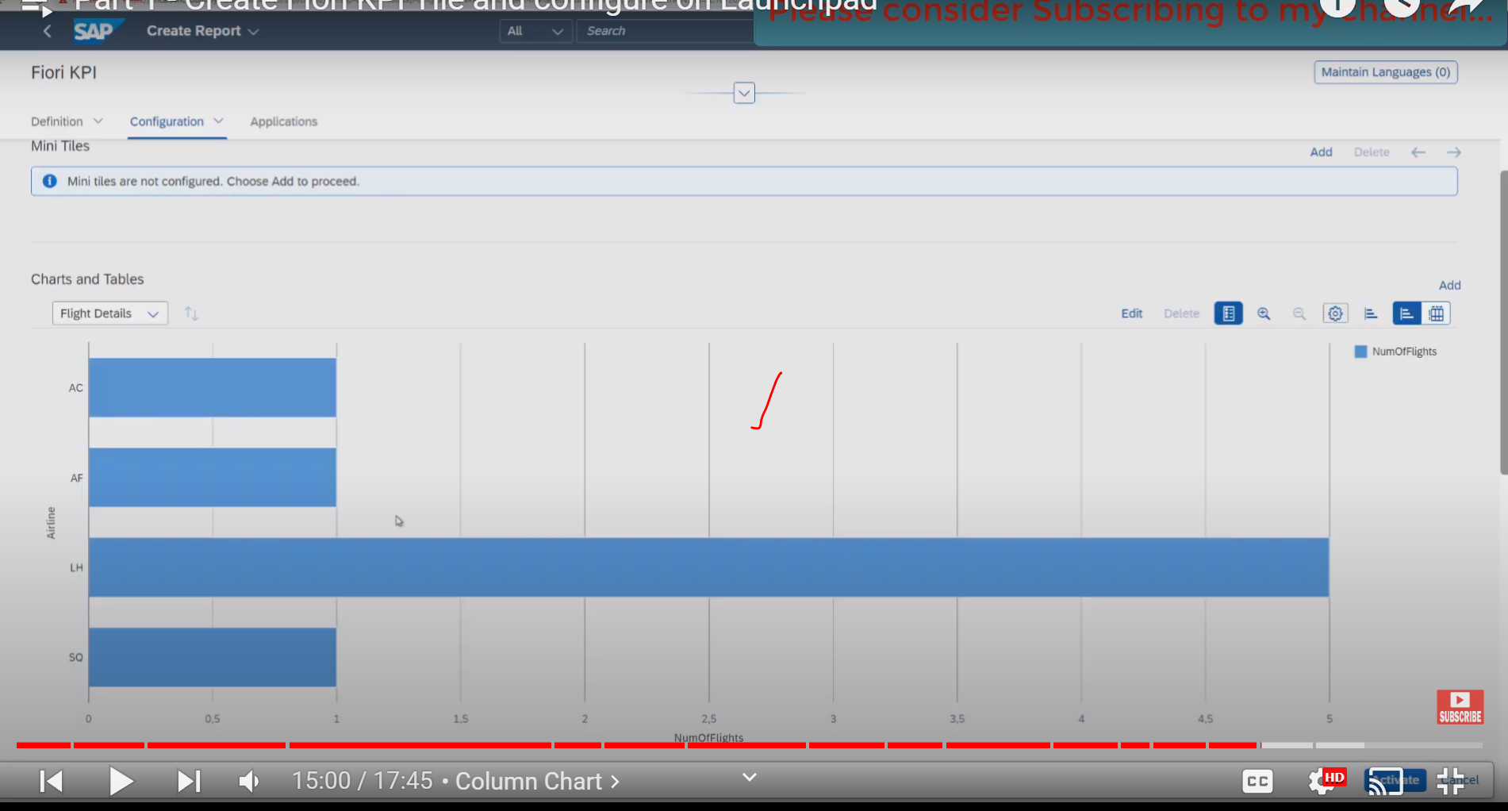

Now we see the different airlines available for the number of flights which they have,

This Horizontal Chart, what if they want to other charts

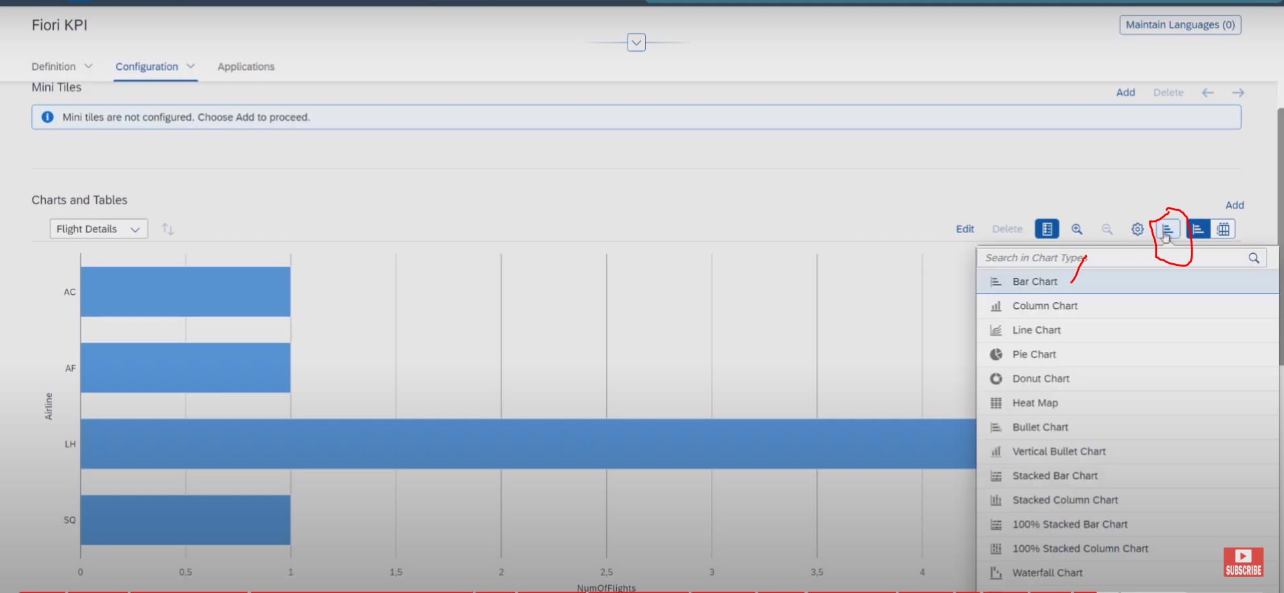

Vertical chart: choose the column chart

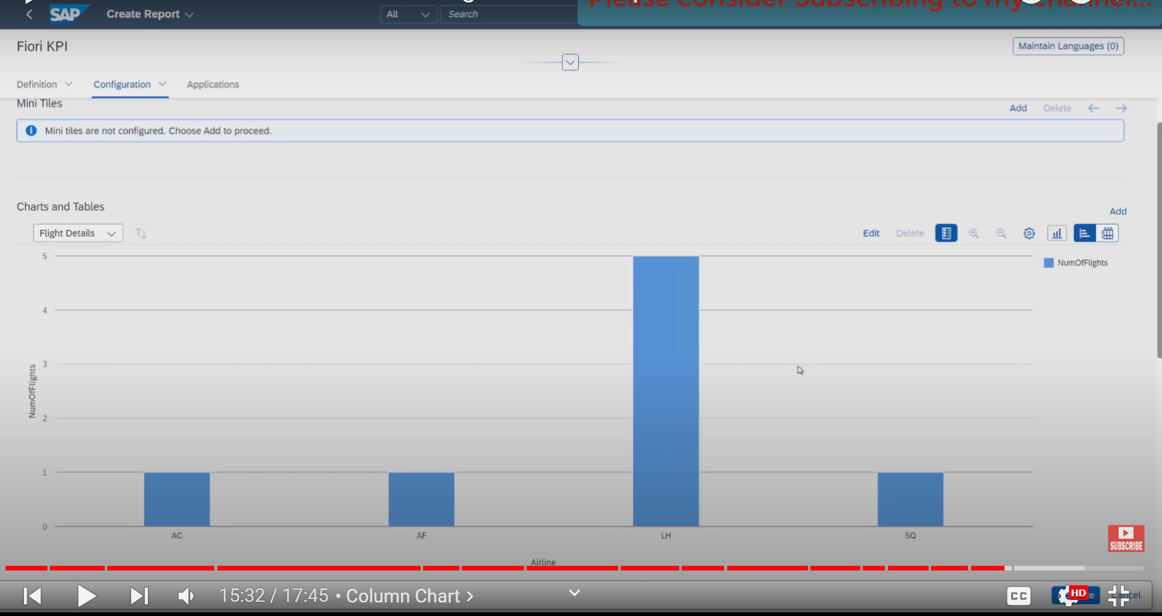

Now report is ready . click on activate the reports.

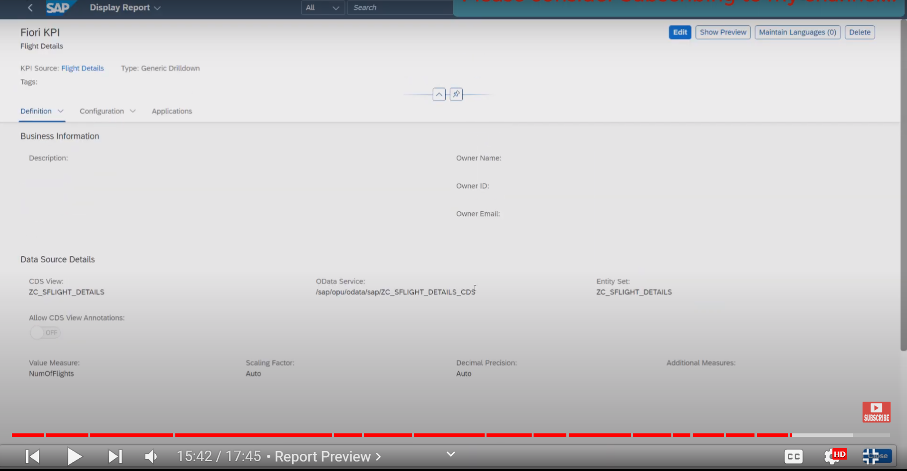

Now report has been activated

Now click on show preview button

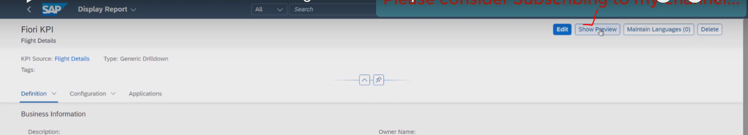

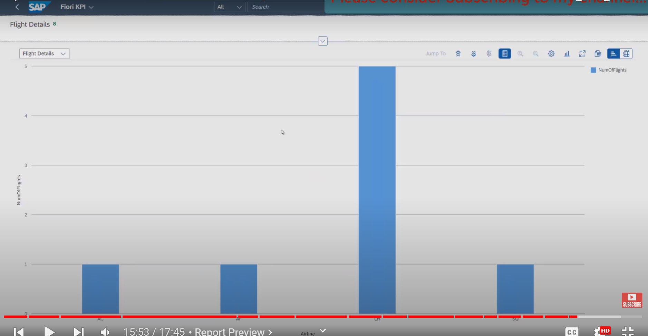

Now report has been activated and completed.

Now create the catalogue : where tile will be added.( for this again we are using the same tile with different options)

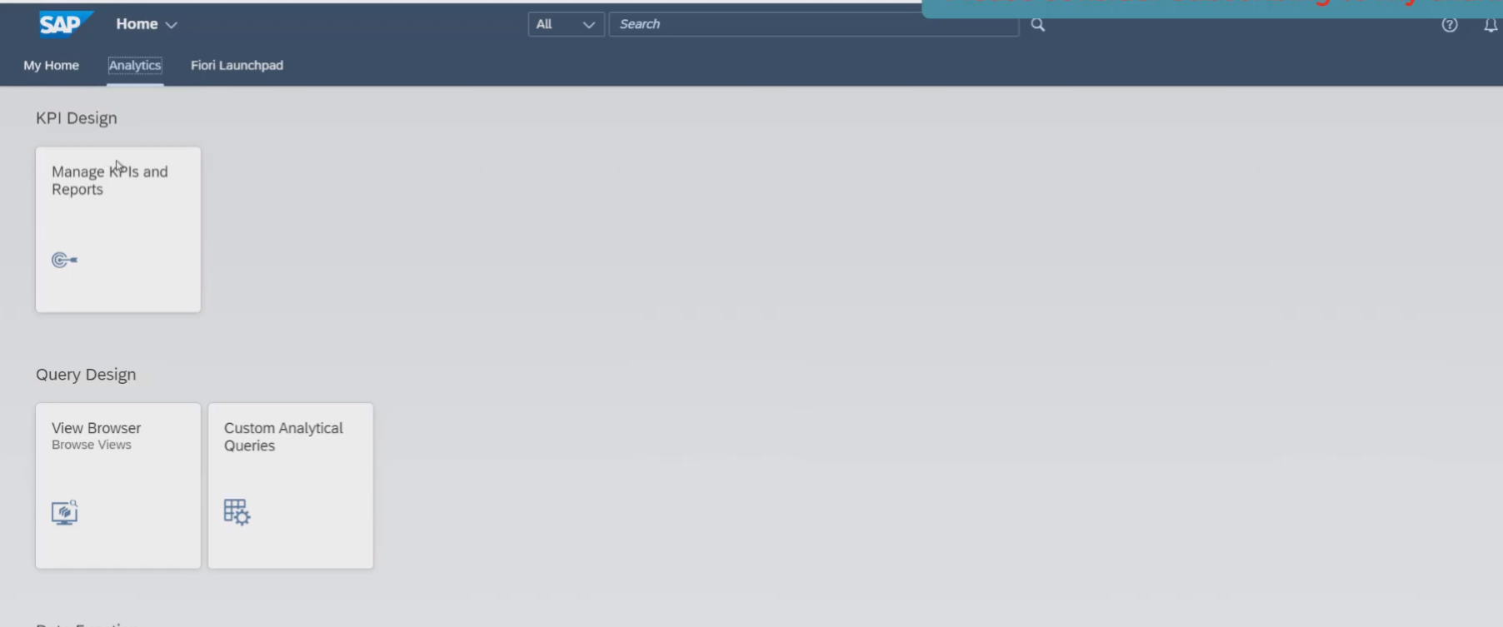

Before we continue new to create the KPI tile for our drill down report we need to have catalogue created where our tile would be added.

To create the catalogue we have the tab :Fiori launchPad available, it has couple of different applications/tile available.

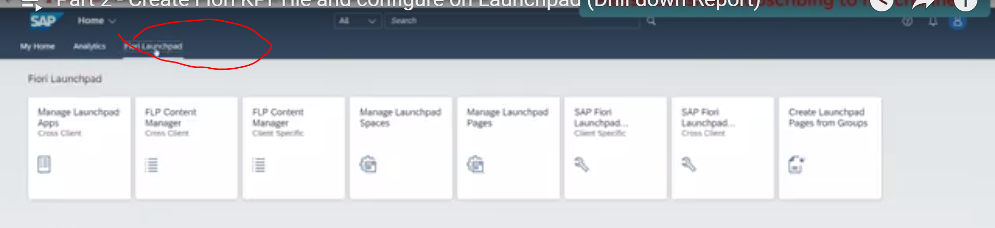

From these tiles we have the SAP Fiori Launchpad designer , select that.

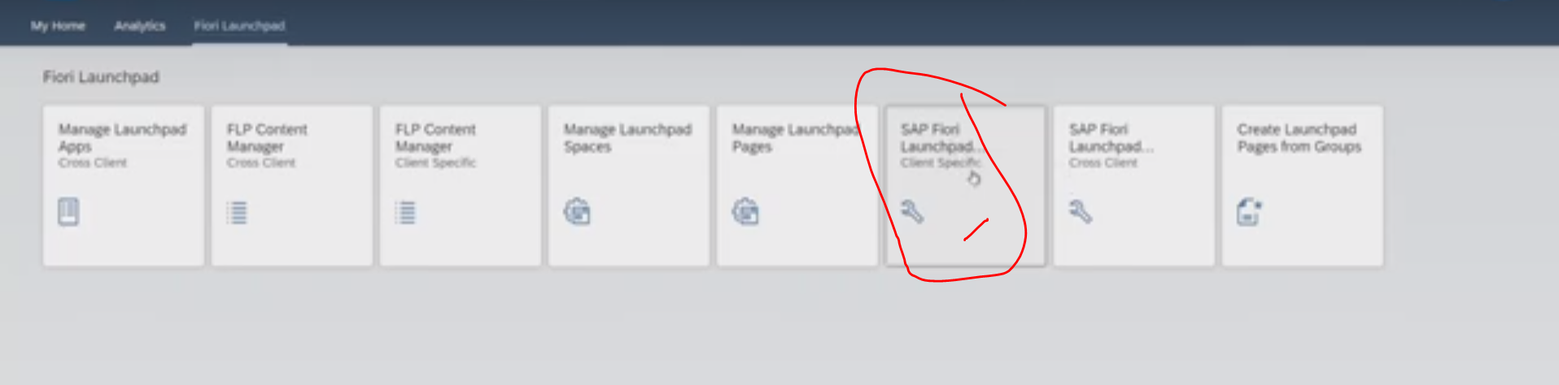

Once click that SAP Fiori Launchpad, it will open the Groups and Catalogues.

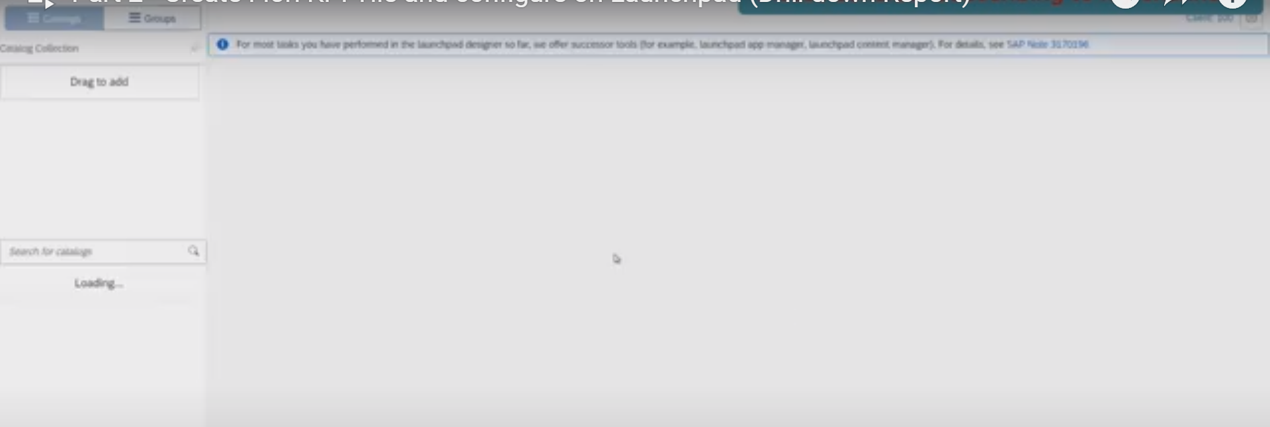

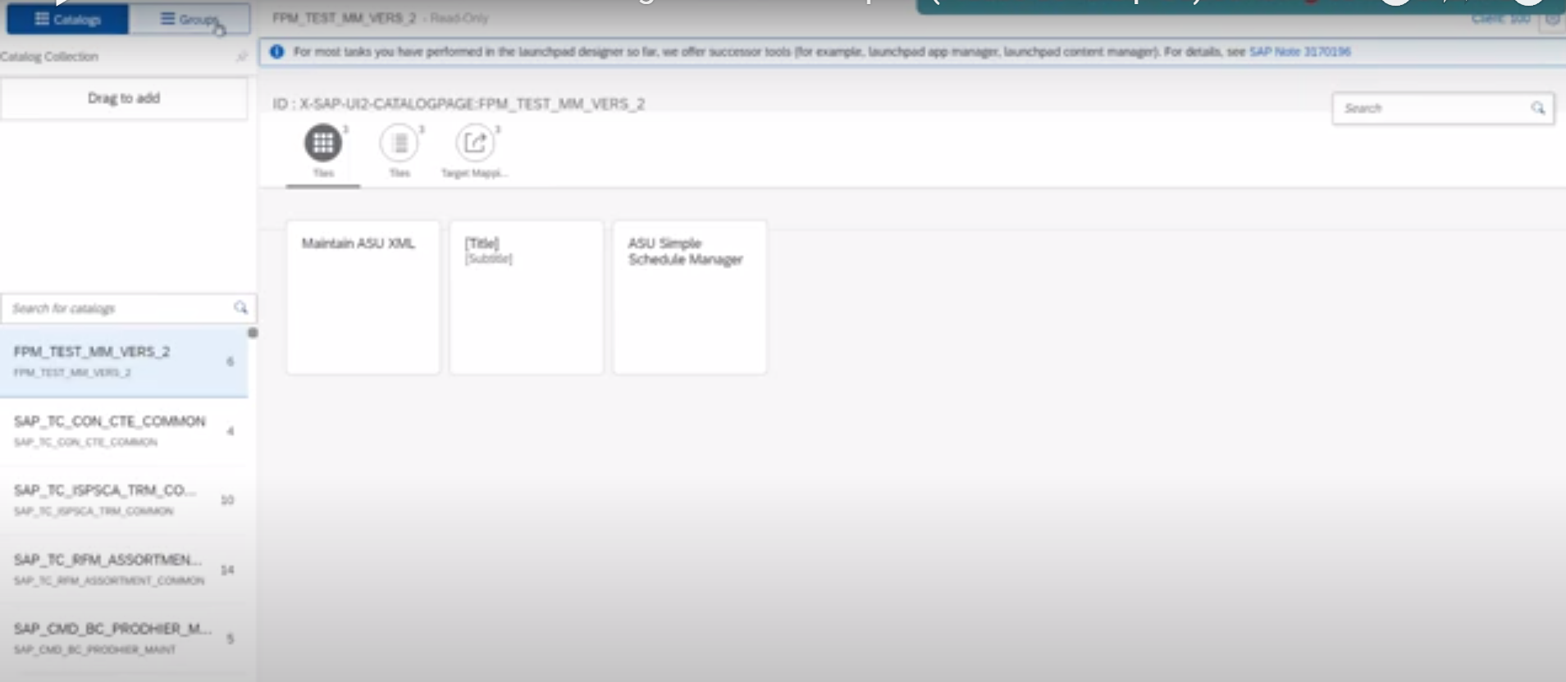

Now click on catalogue : click on + button to create the New catalogue.

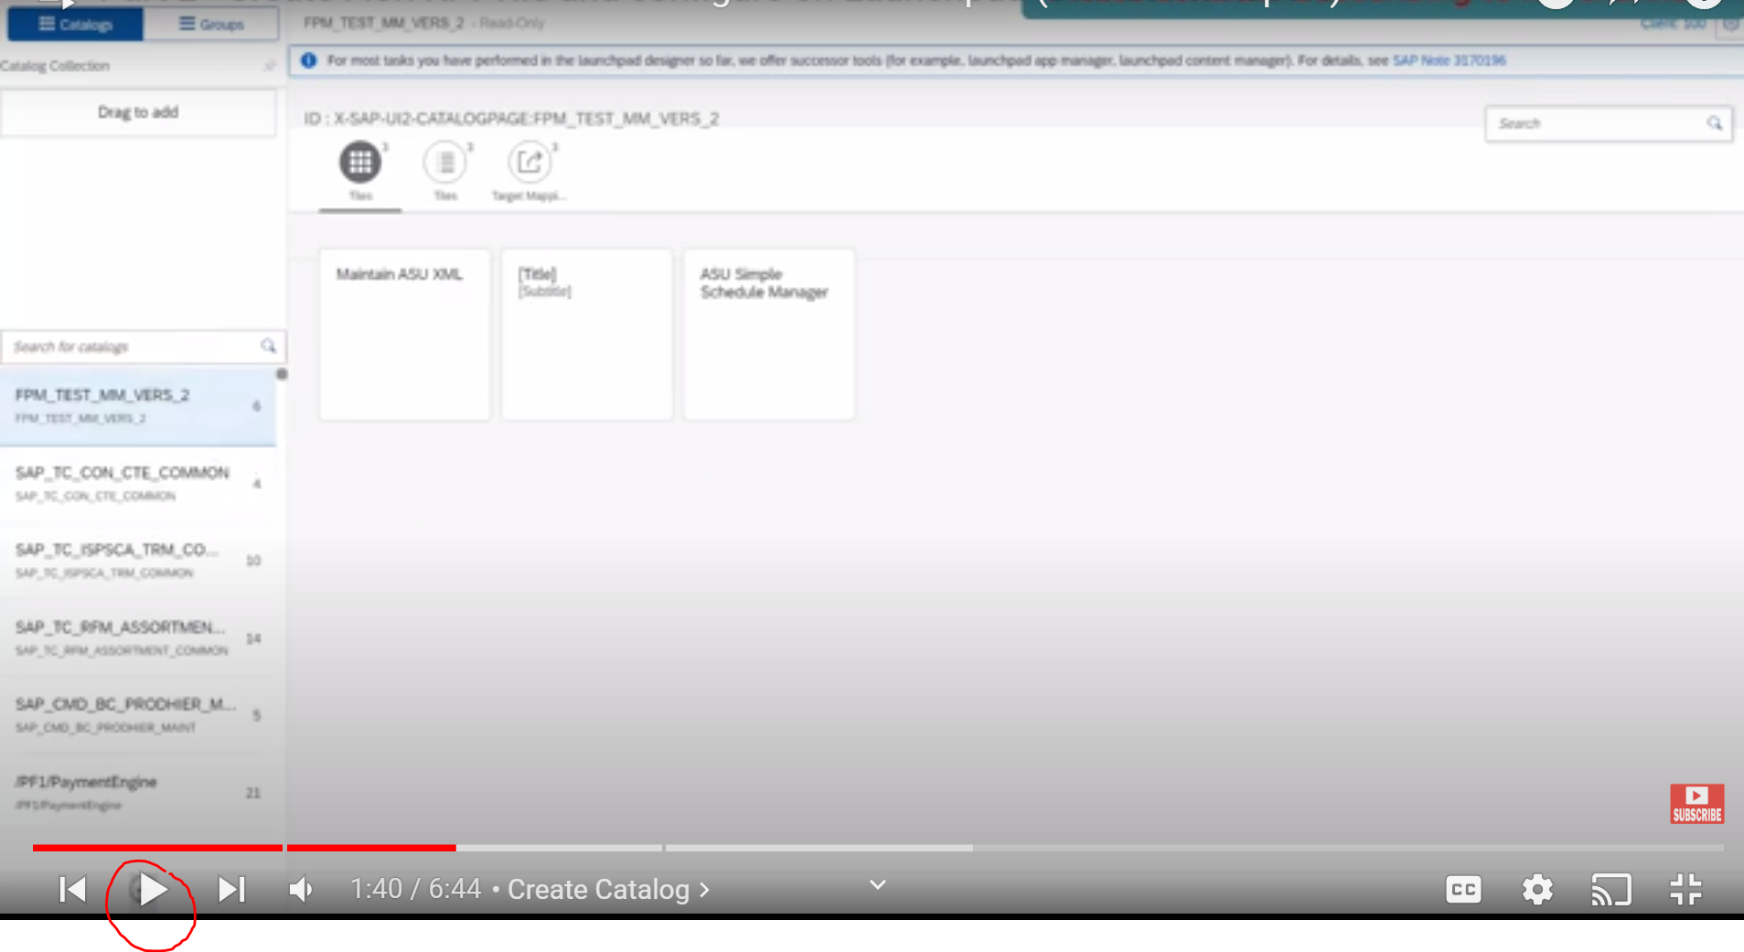

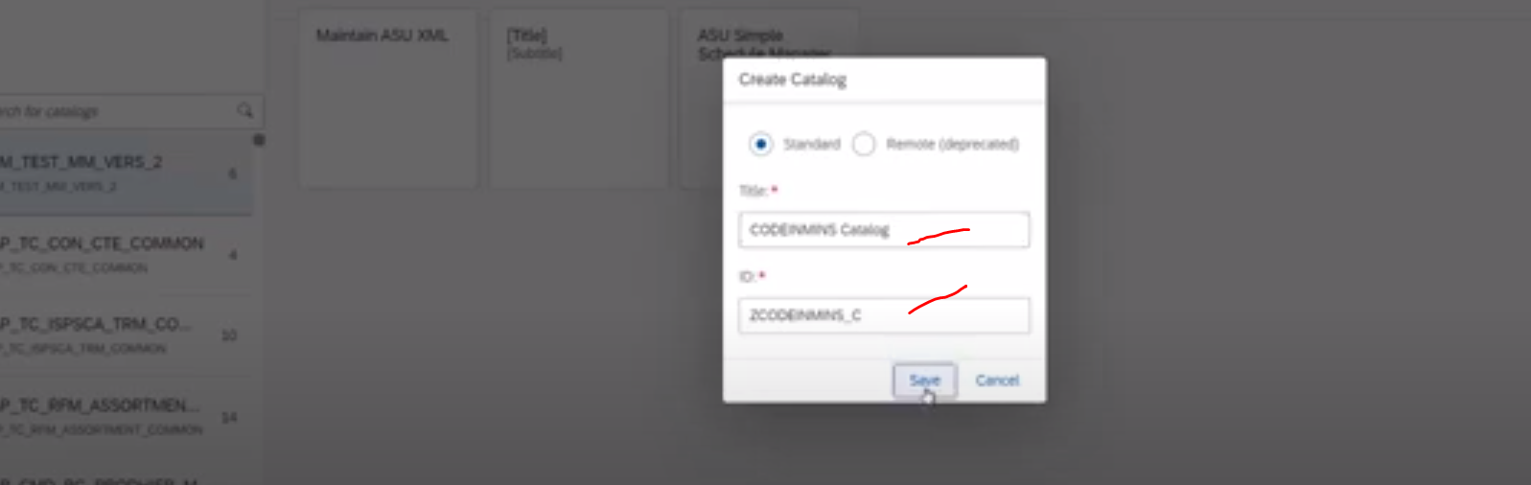

Tile :CODEINMINS Catalogue

ID: ZCODEINMINS_C

Click on SAVE

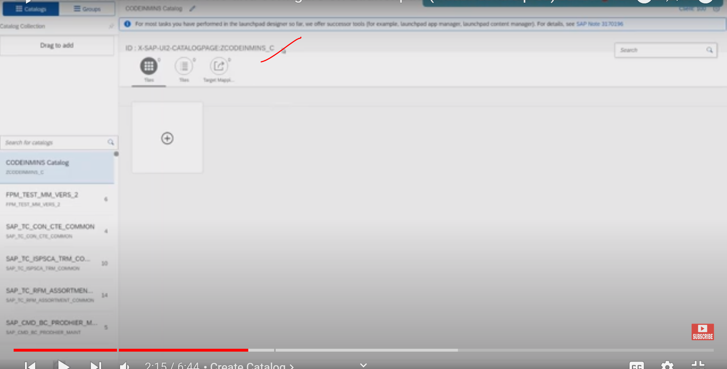

Now our new catalogue has been created -Nothing else here..

Now go back to Home screen.. and click on analytics tab

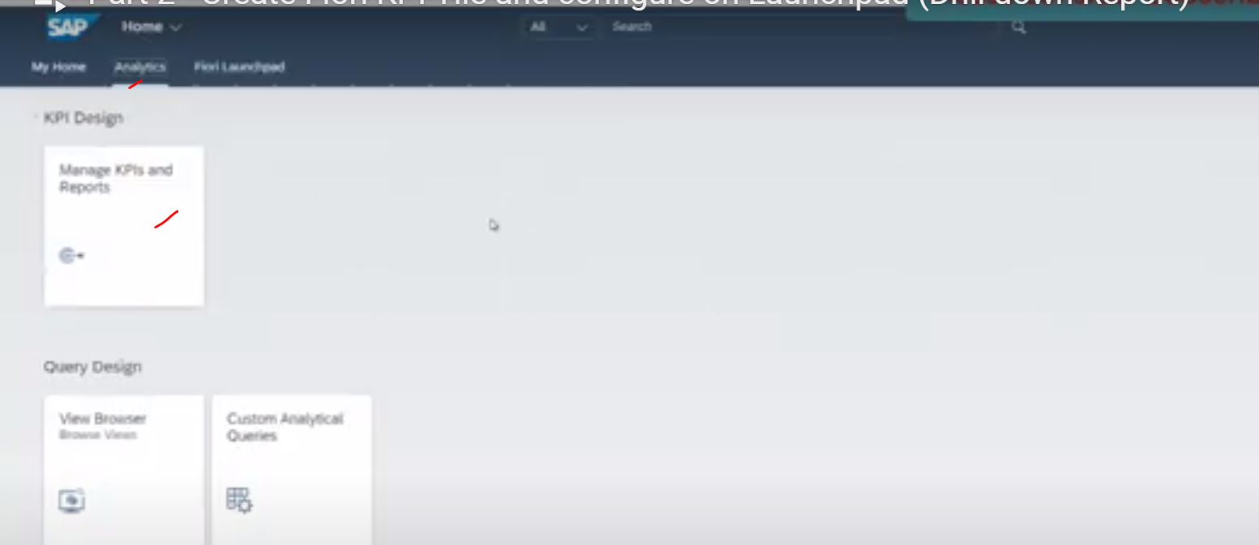

click on manage KPIs

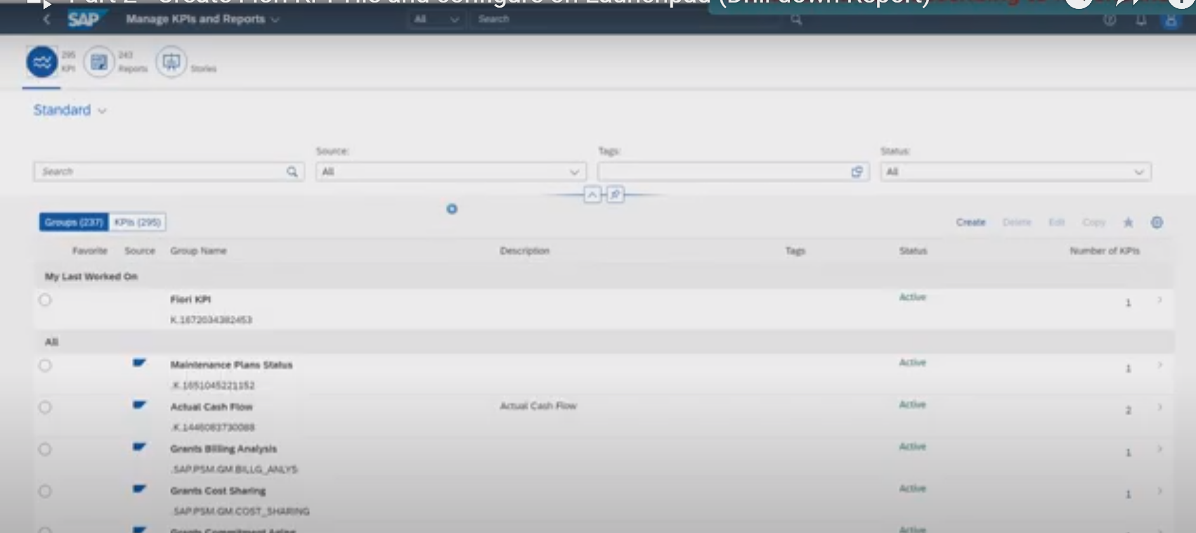

Now it is showing with already created group: Fiori KPIs

click on Fiori KPIs Group

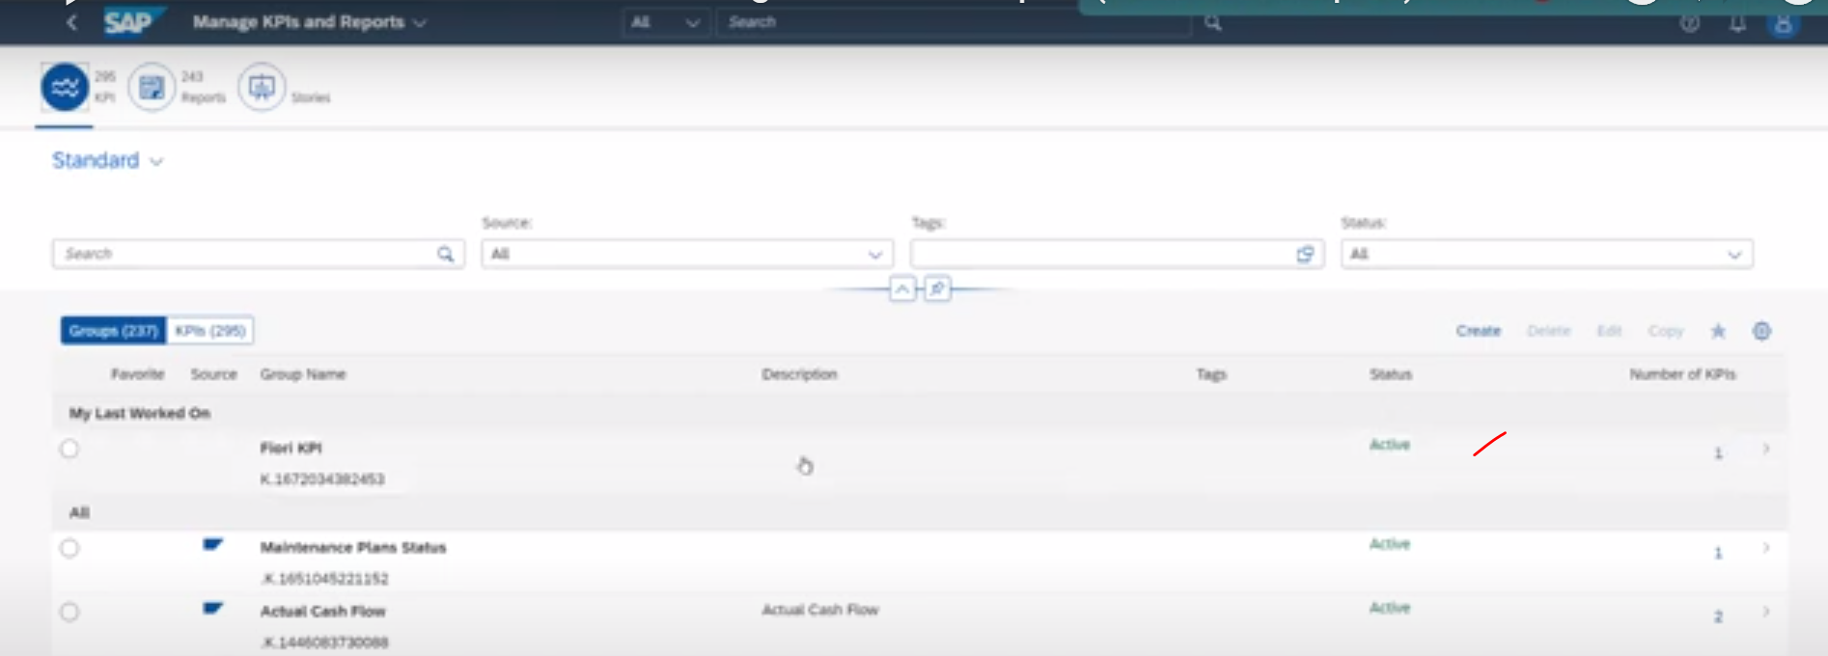

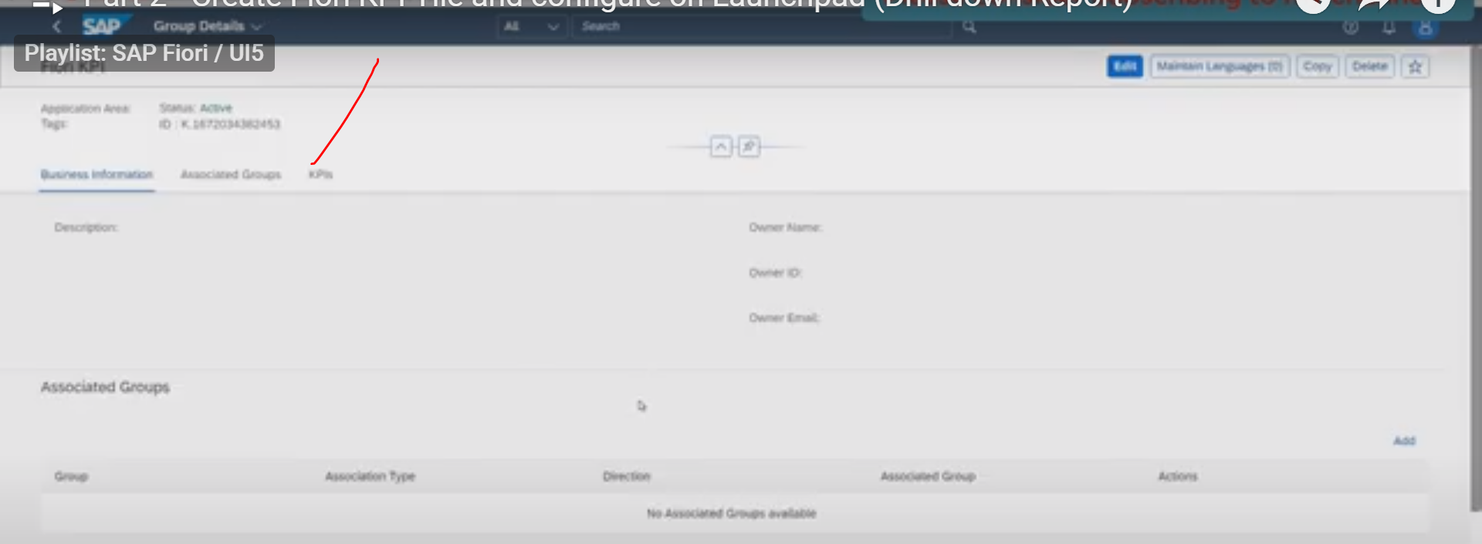

click on KPIss

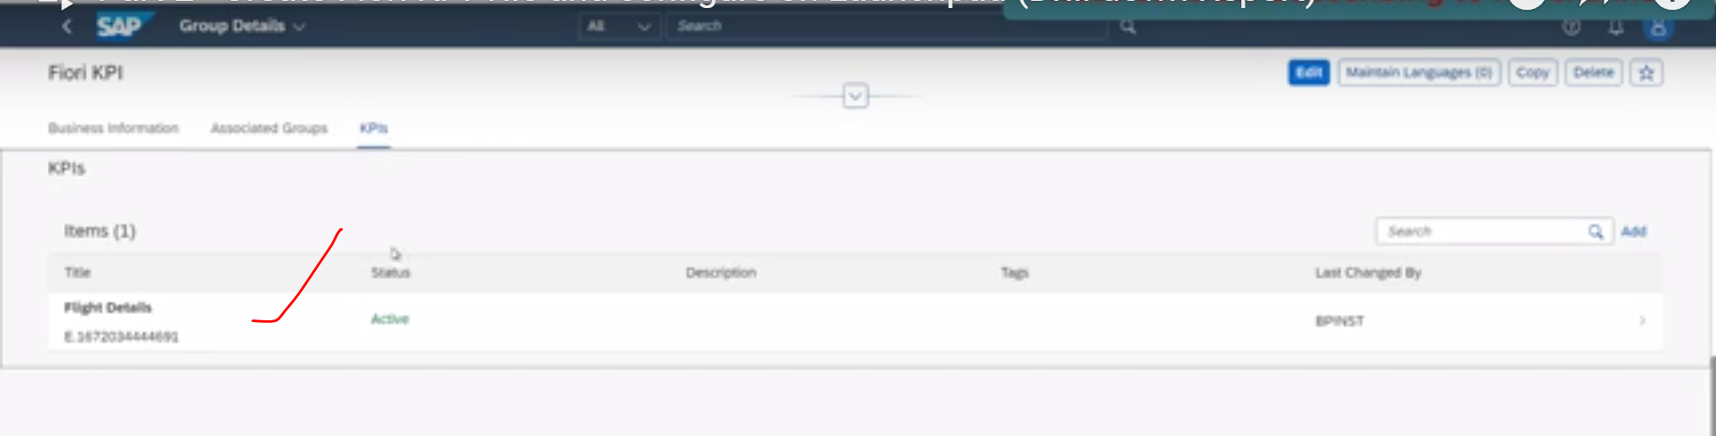

Click on Flight Details

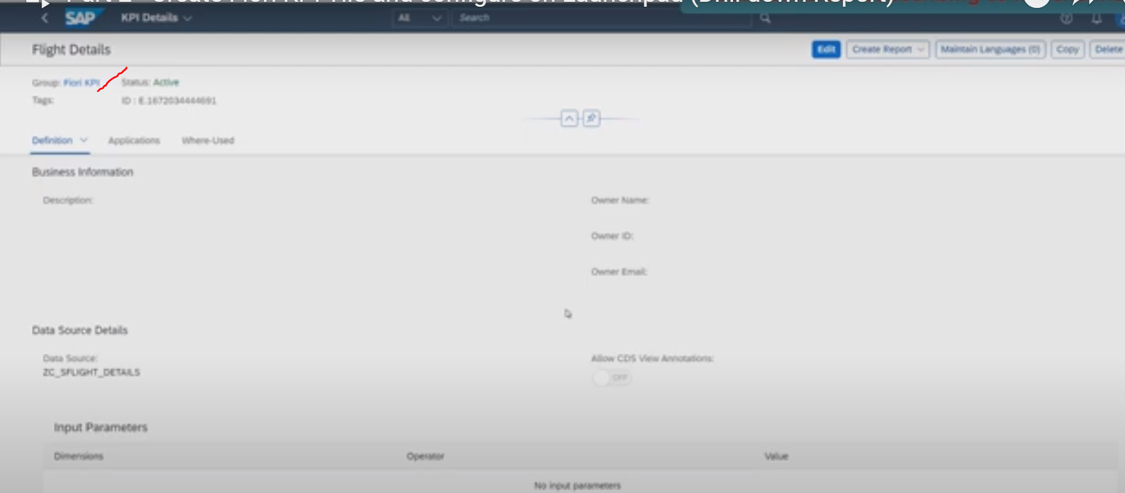

Now click on Applications tab:

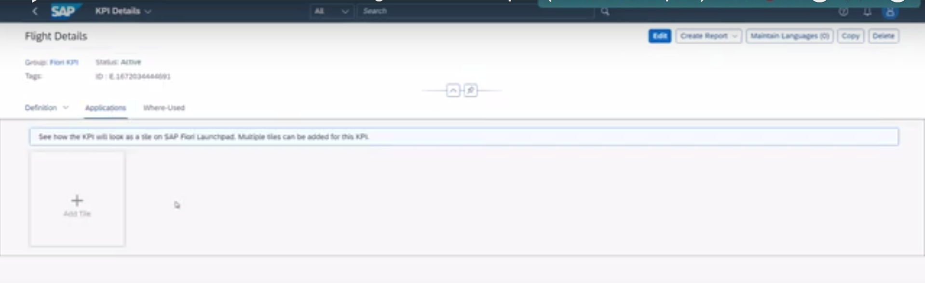

This is the place where we will be creating our new tile.

click on Add tiles

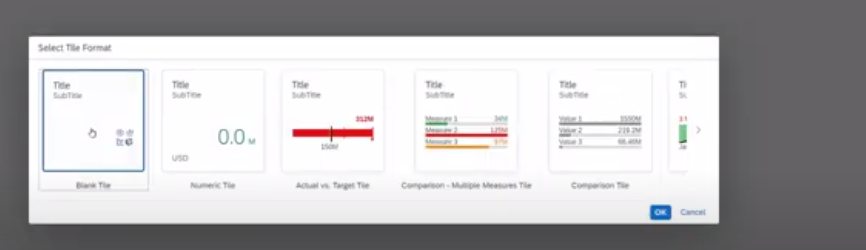

Select the Tile Format. Note: we are using S4HANA-2022 system

Select the numeric tile : on tile we will be showing the total number of flights.

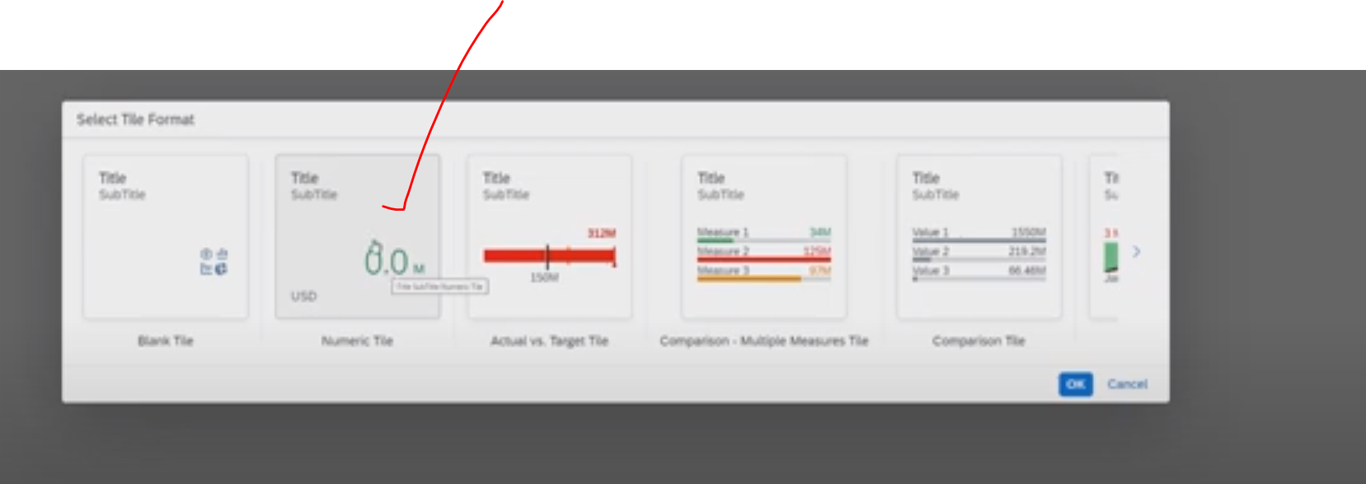

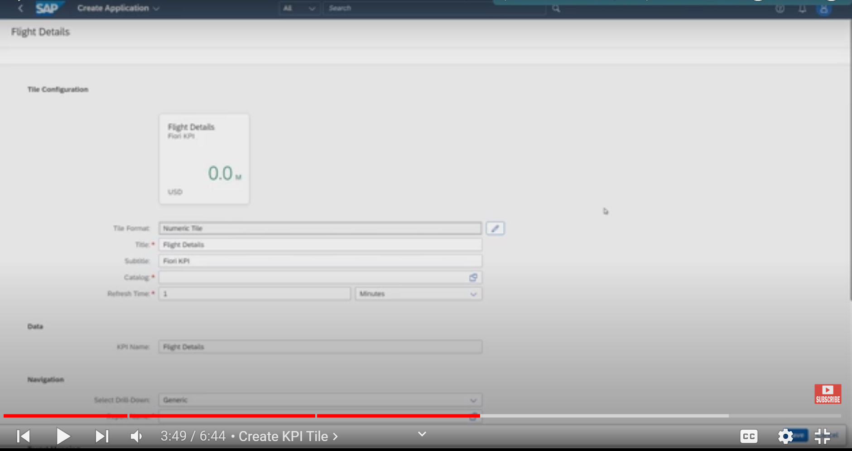

Now add the catalogue here: that was the reason we have created the catalogue first

Click on F4 catalogue : select the created catalogue.

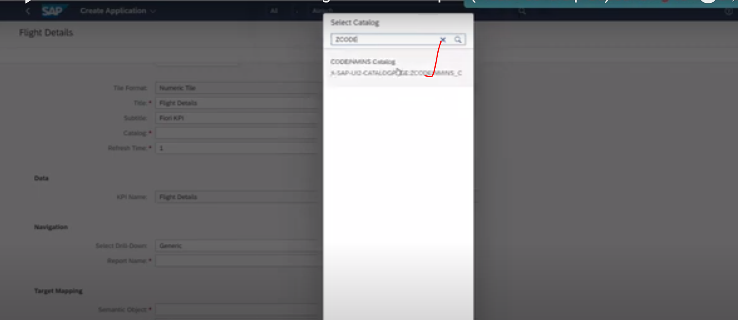

Refresh time: means tile will be refreshed after the given time automatically, you can change the your requirement.

Select the report name: press F4 help(Whatever reports you have created those are available)

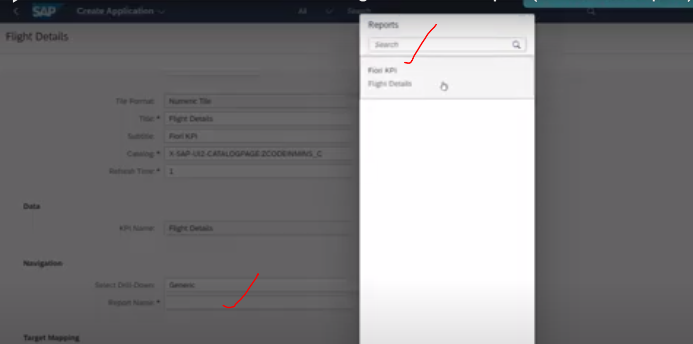

Select the semantic object:

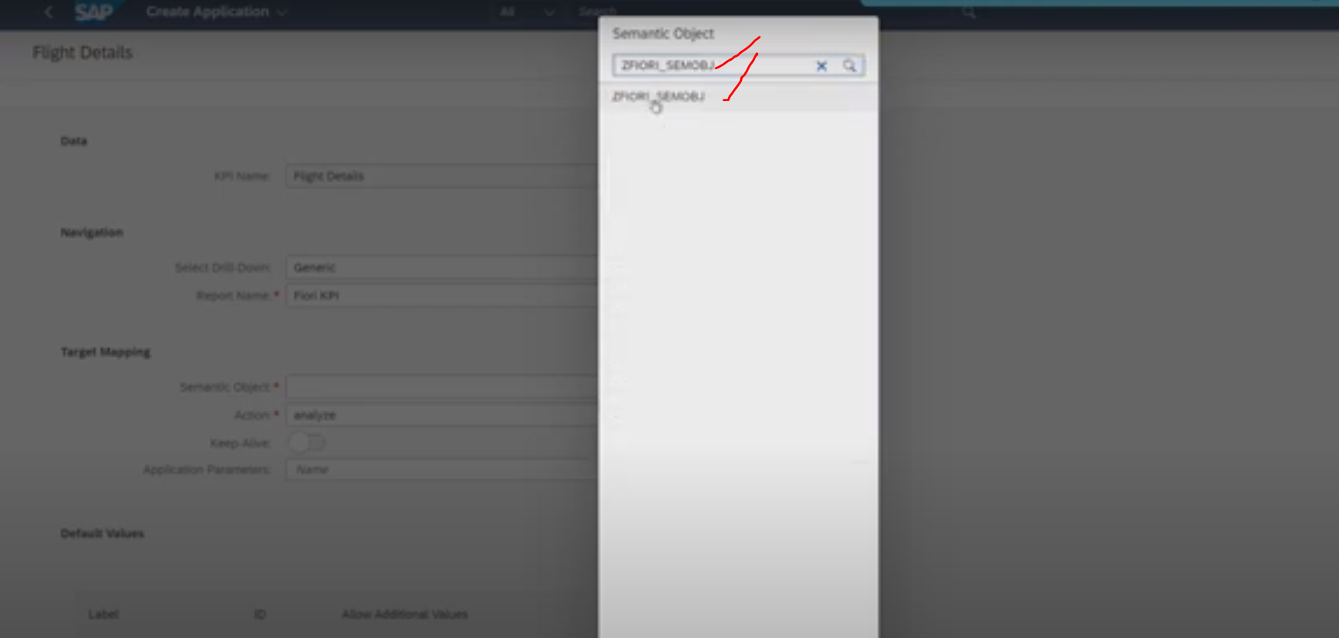

Action :Analyze (Default)

Click on Save

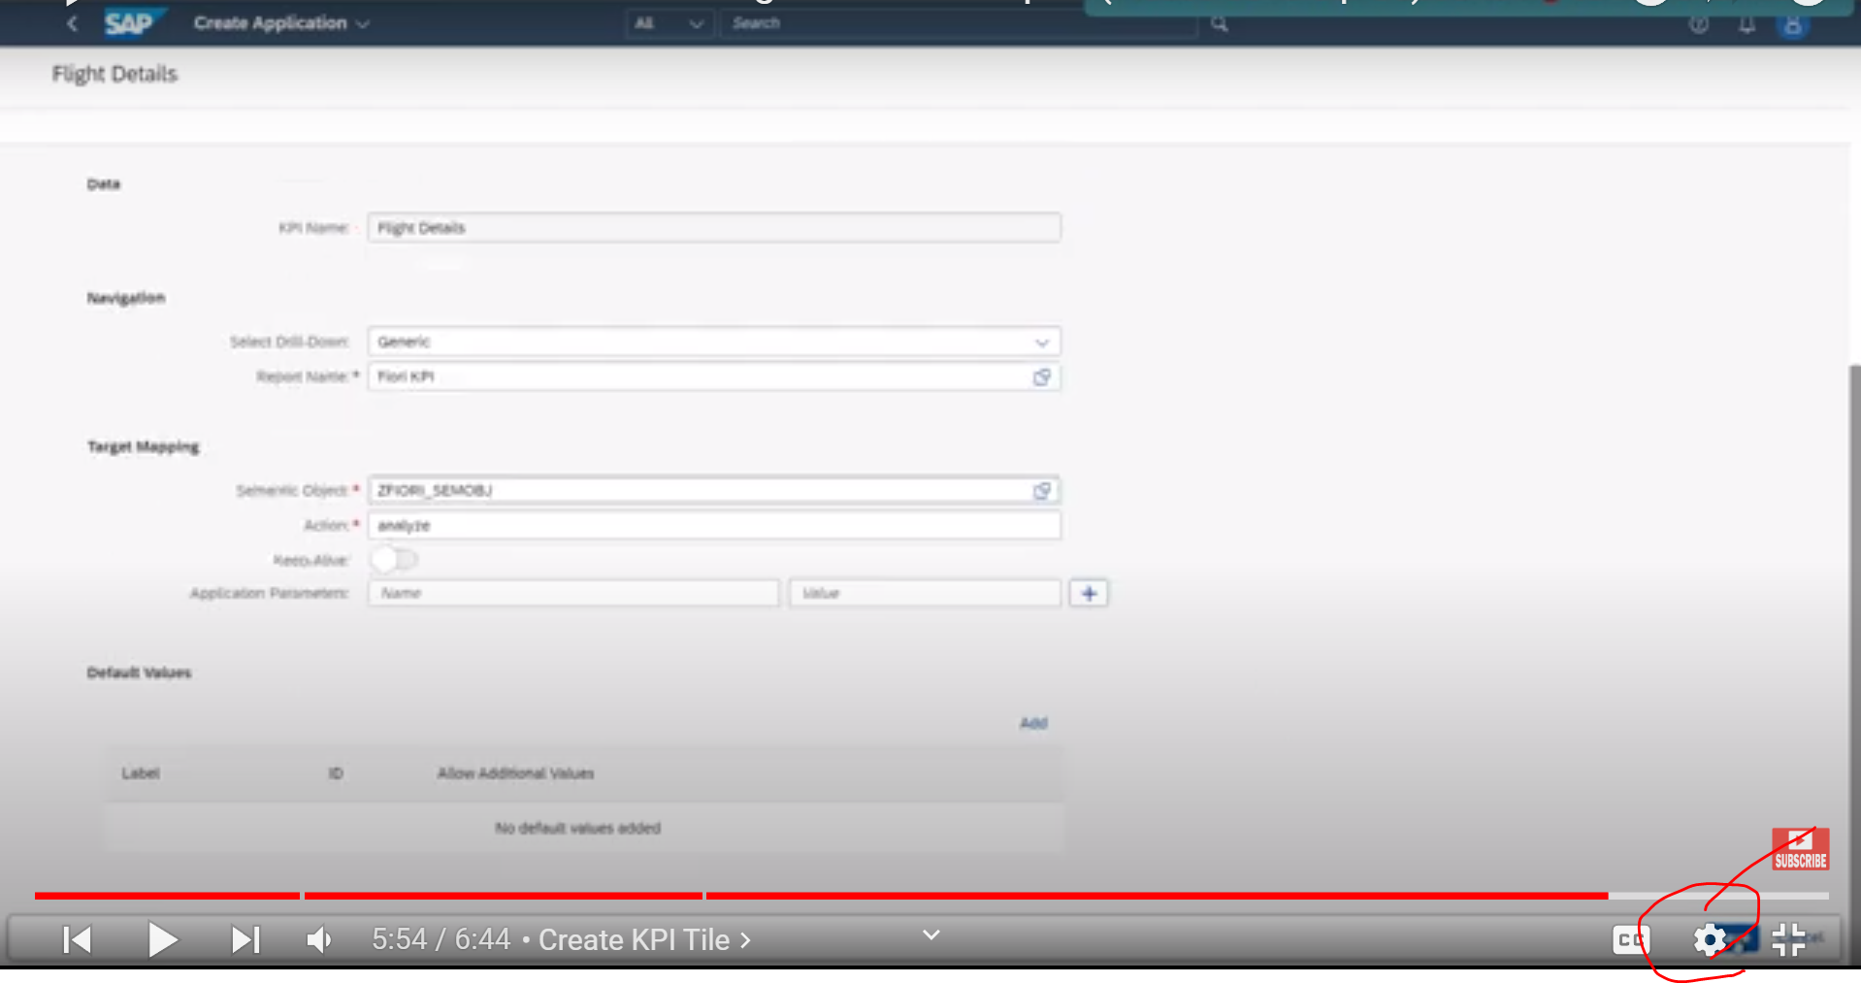

The information has been saved successfully.

Now Home screen appears: 🡪 click on Application tab:

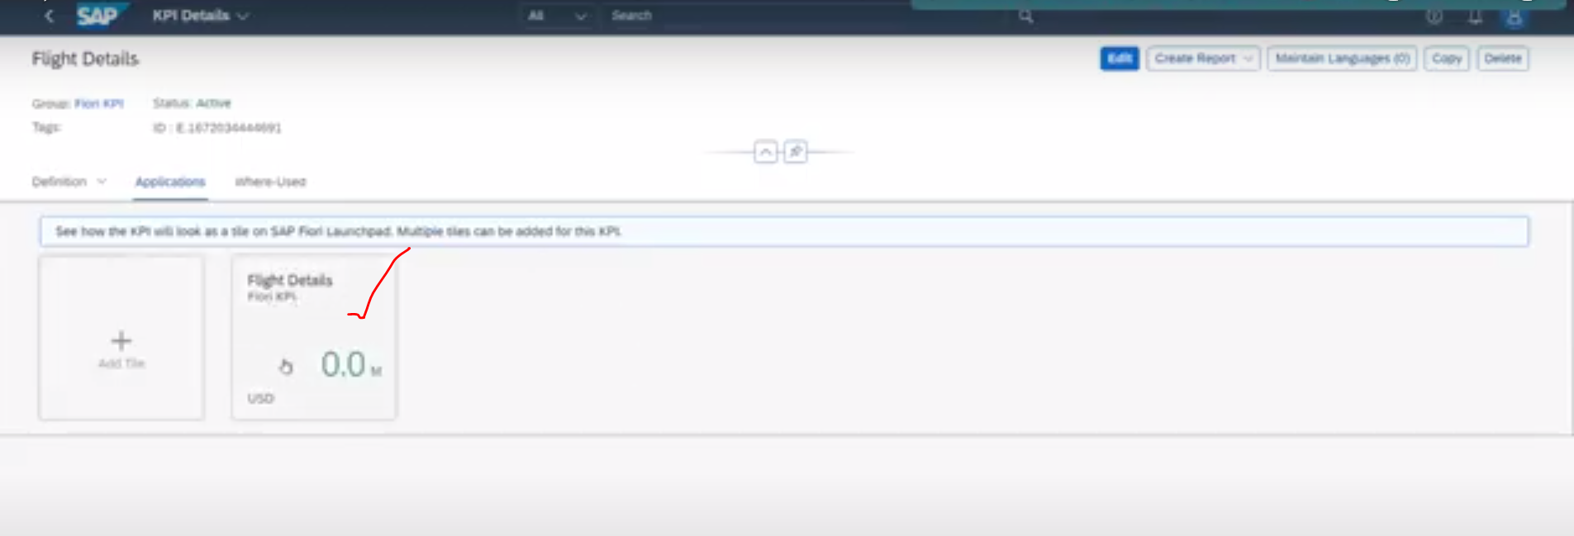

Now tile appears which has been created.

Next screen: we will attach these tiles in Fiori launchpad using -spaces and pages concept.

Part 3

Add KPI tile to Fiori Launchpad Using Pages and Spaces:

What is pages and Spaces?

* It is available S4HANA-2020, before this we normally used to have the catalogues and groups for configuring the tile on the Fiori launchpad but from S4 hana, sap recommended pages and spaces concepts for managing the tile on Fiori launchpad. Still available catalogues and groups but SAP will support pages and spaces only.
* It is also rolling out all of the new Fiori applications and Fiori tiles under the pages and spaces.

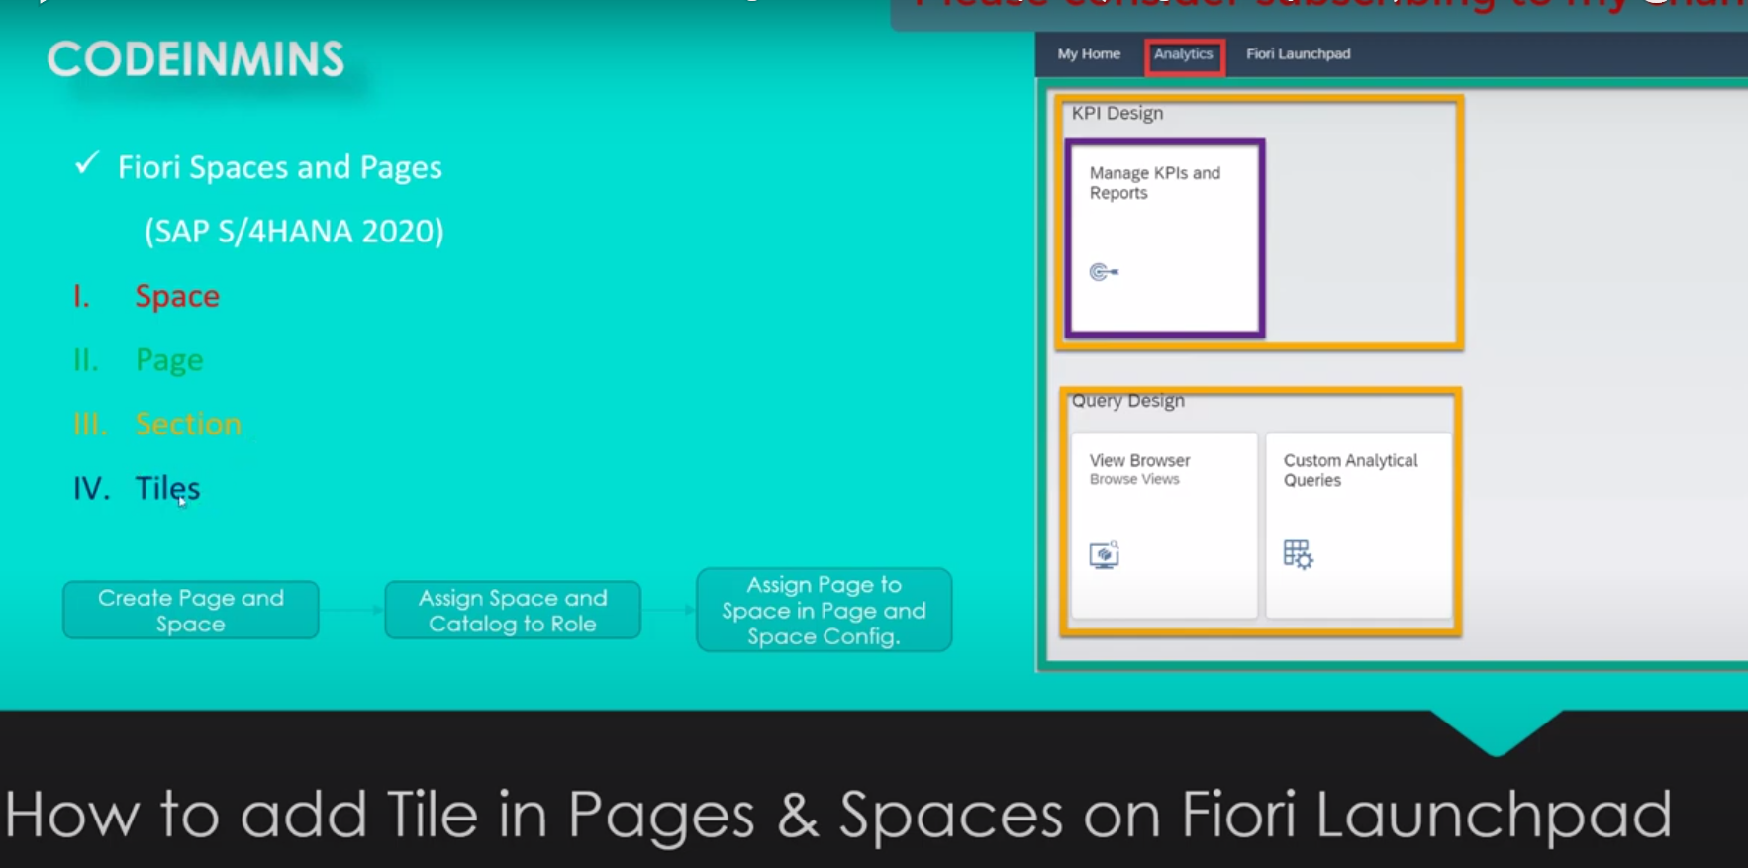

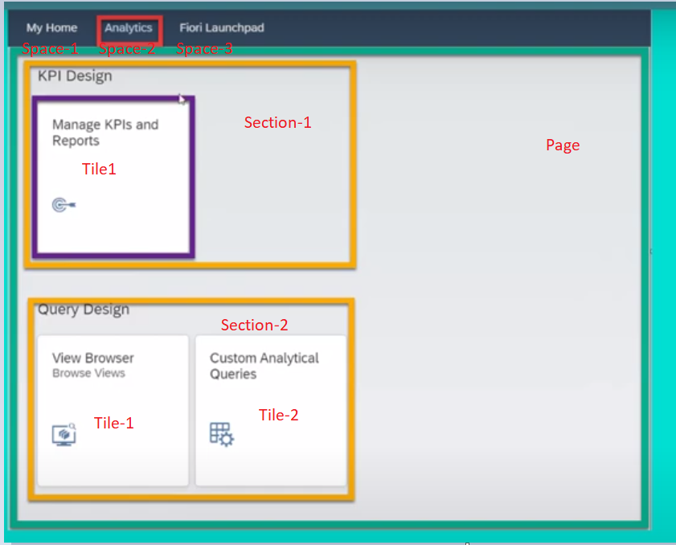

Space – Page – Page Contains Multiple Sections – Each section has multiple tiles.

Space(1) 🡨🡪Page(1) 🡨🡪Sections(m)

Section(1) 🡨🡪Tiles(m)

Here :

1. MyHome/Analytics/FioriLaunchPads 🡪 are spaces.

Step-1 To configure the pages and spaces use the pages and spaces to configure the Fiori tile.

Flow:



Note : If you are not seeing the pages and spaces 🡪 Click on user profile 🡪click on settings 🡪Next screen Go to the pages and spaces sections

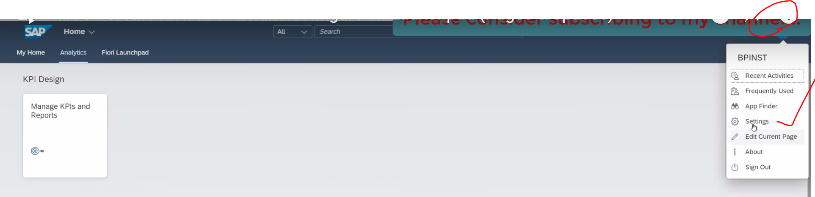

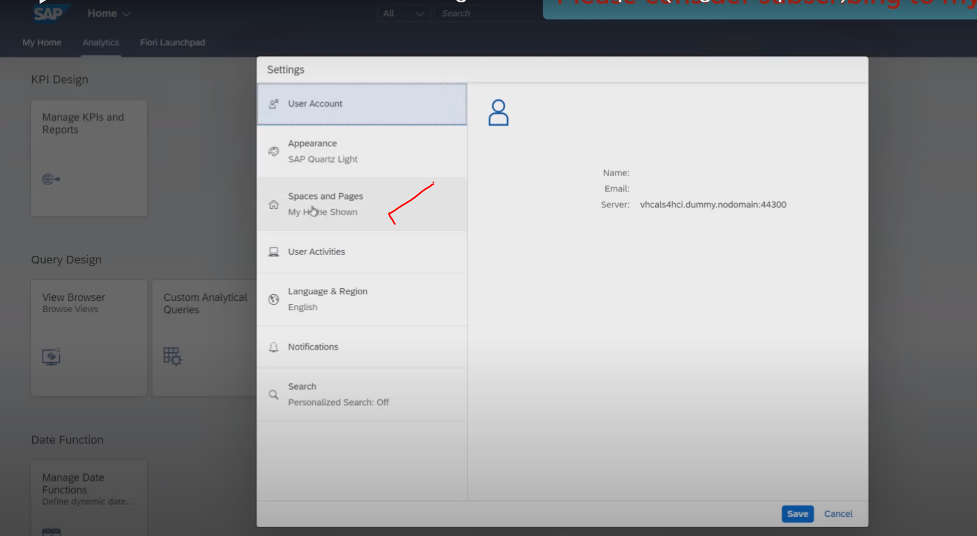

When you click on pages and spaces 🡪 check the use Spaces check box has checked or not 🡪 if it is uncheck, please check it only for spaces and pages

Pag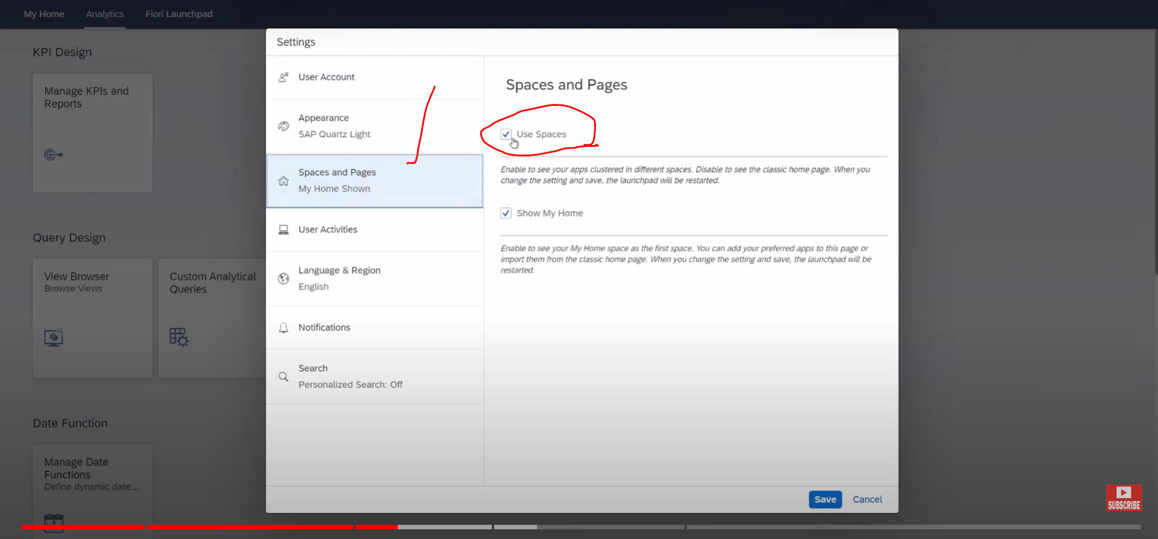

If it is checked – Fiori launchpad following the Pages and spaces concept guideliness.(5:30)

If it is uncheck – then you will see all of the applications which are configured using groups and catalogues.

If it is check and save -> launch pad will be refresh and you will be navigated to all of the tiles are the applications which are under the pages and spaces versions.

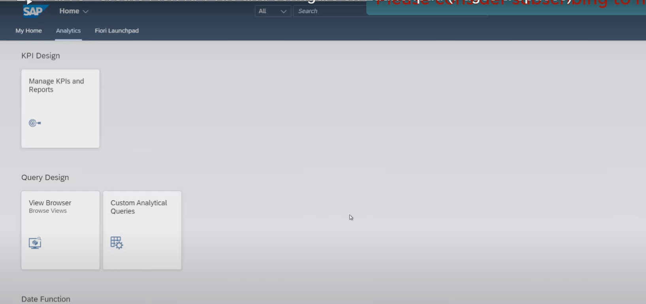

Now to configured the create the pages and spaces.--> we need go to Fiori luanchpad.

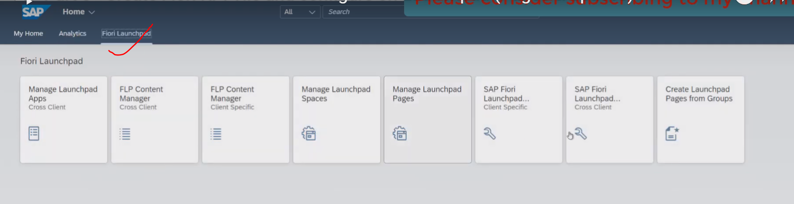

Here we got the couple of applications for all, which we need to select the manga launchpad spaces applications.

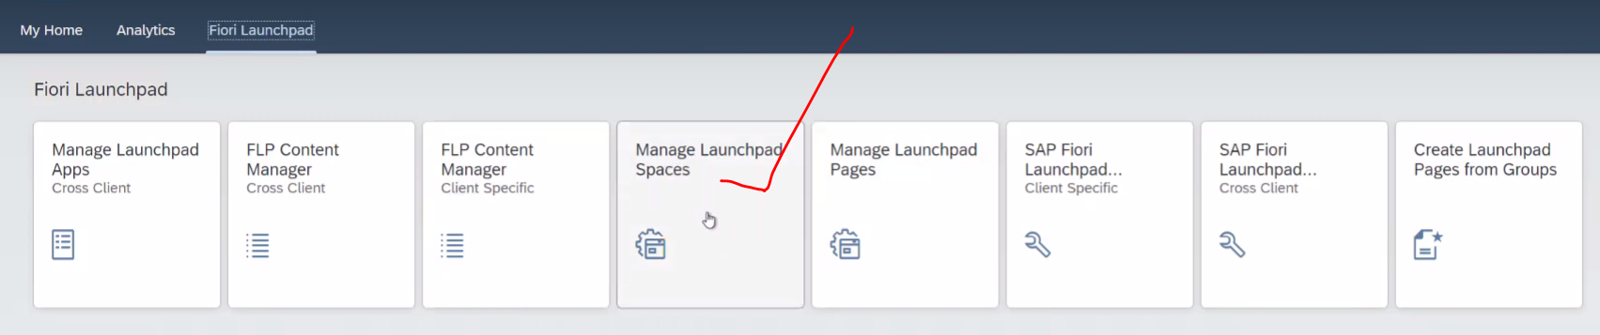

Click on Manage Launchpad Spaces tile 🡪Next screen will appear as below

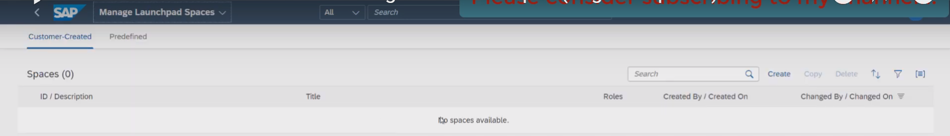

Now we don’t have any space available currently.

Let’s create one space for KPI tile.

Click on create button.

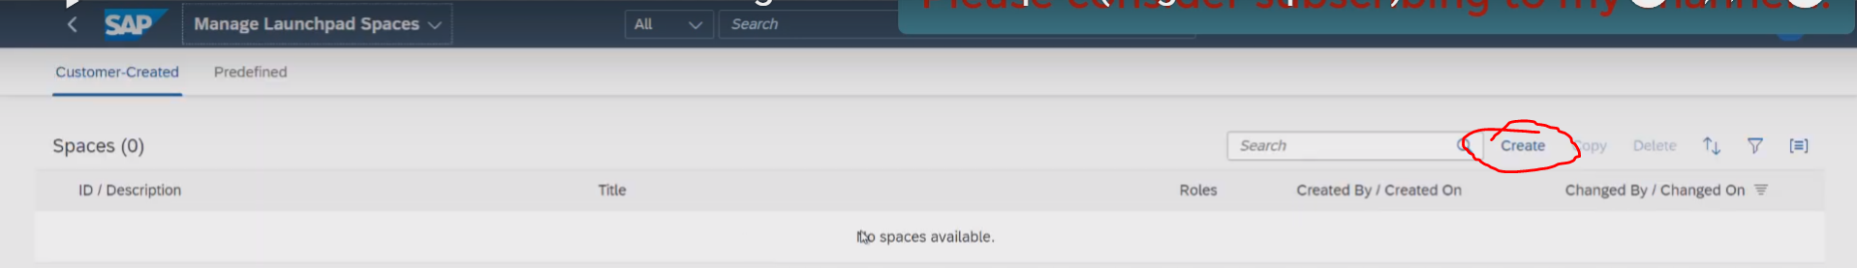

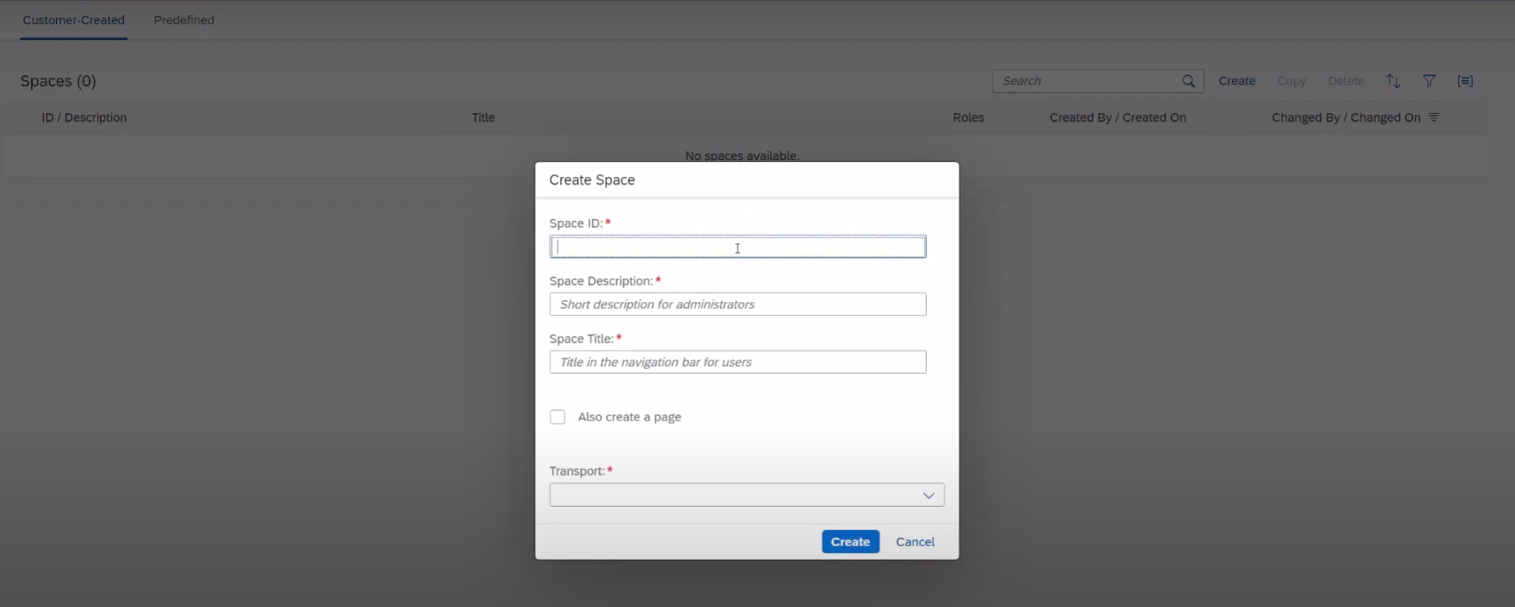provide below details

Space id : ZFLIGHT_DETAILS_SPACE

Space Description: Flight details space

Space Title: Flight details

Transport: Local

Space getting created, we also need the page 🡪 for this we need to check the checkbox for also create a page.--> when it is checked and following properties appears.

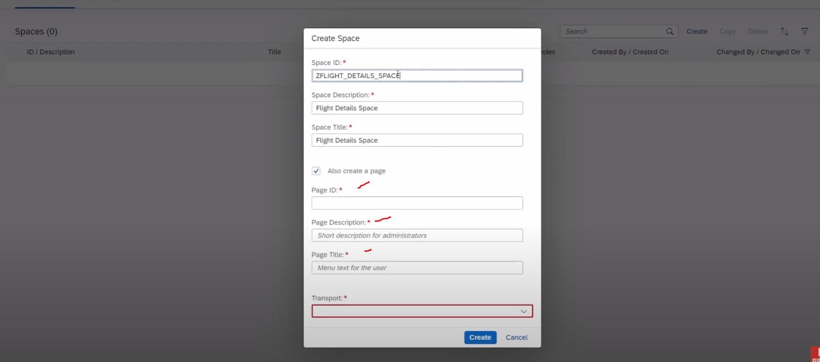

Provide page id, title, description and transport

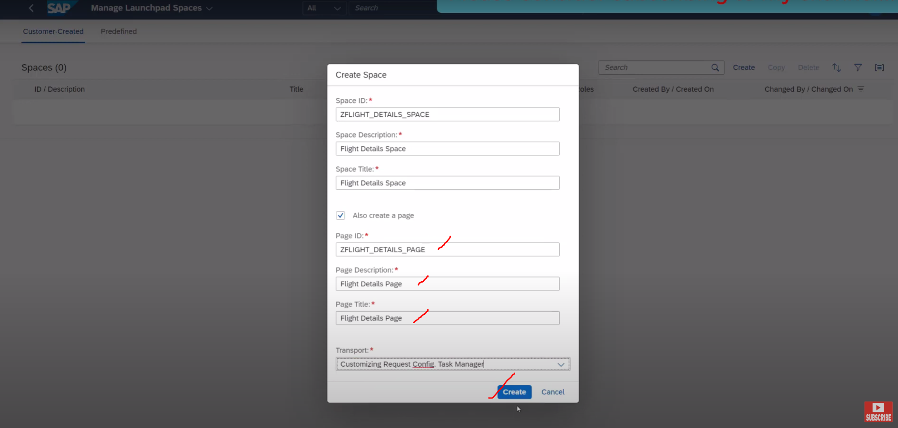

Click on create button.

Now our space and pages has been created.

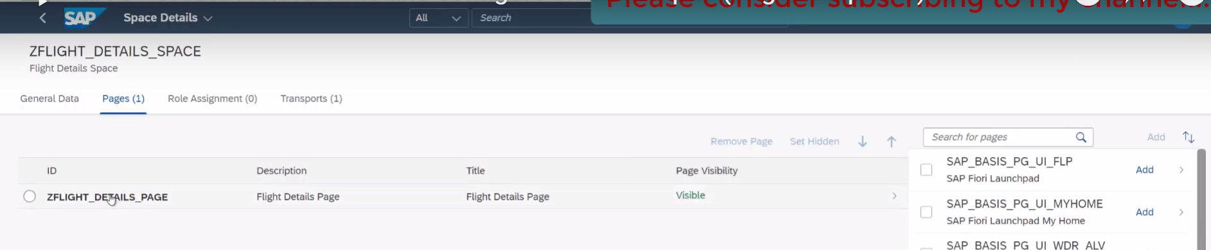

Since this page automatically visible , if it is page visibility is hidden ,need to select this option click on set visibility .

And now click on SAVE button.

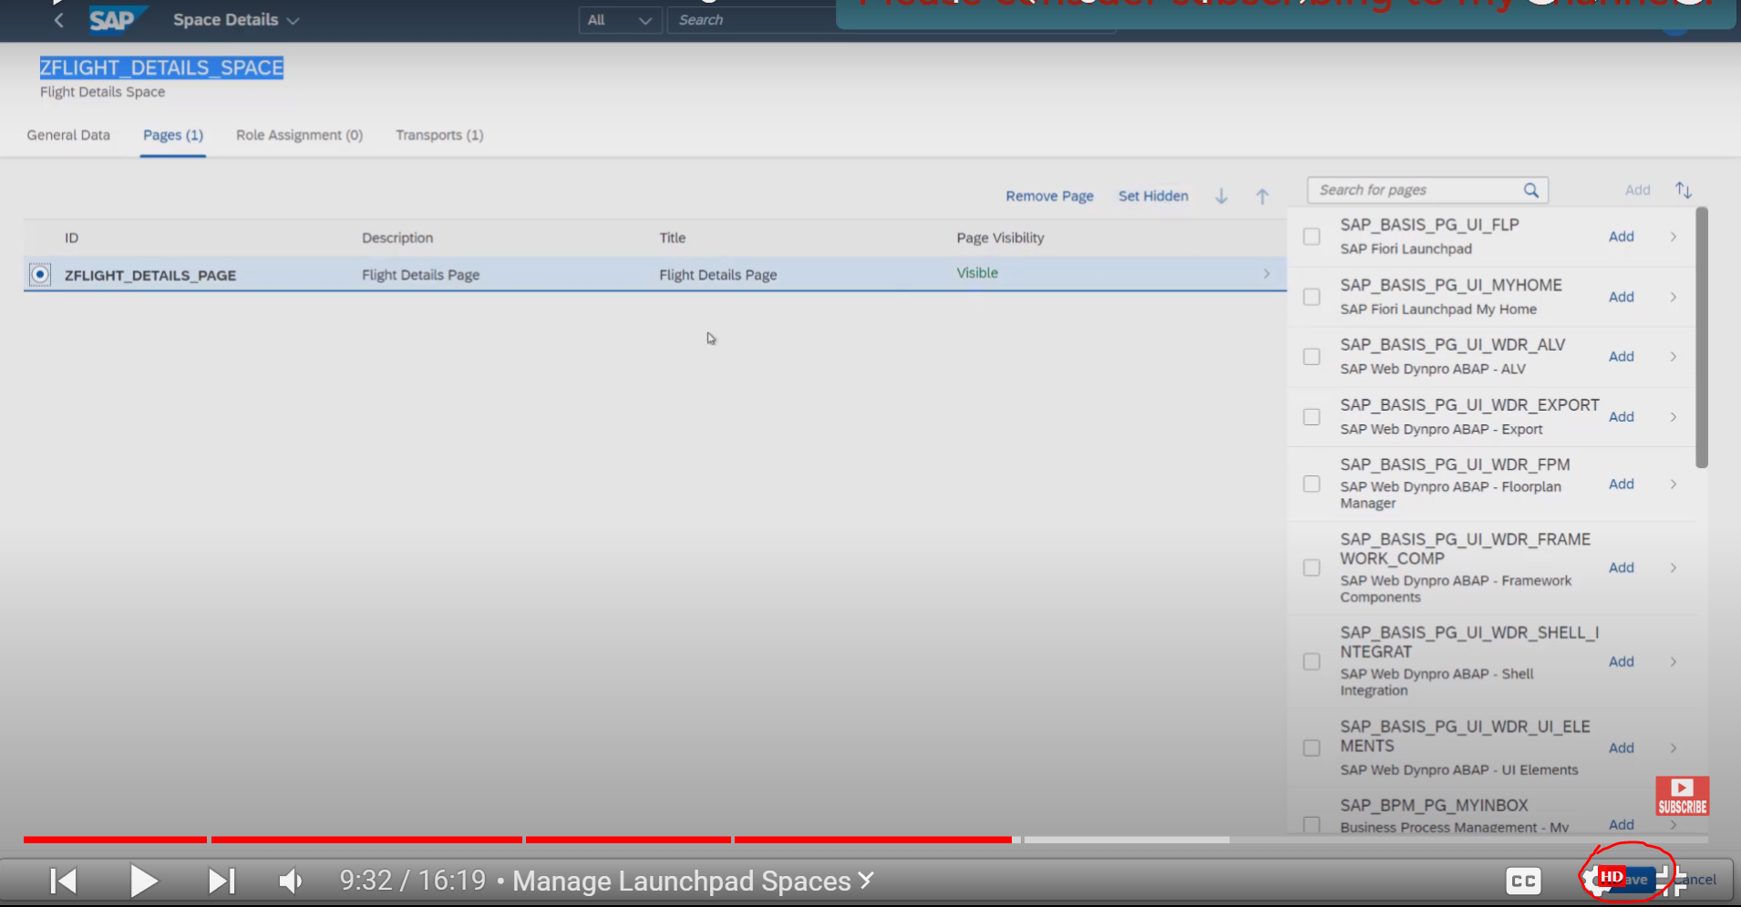

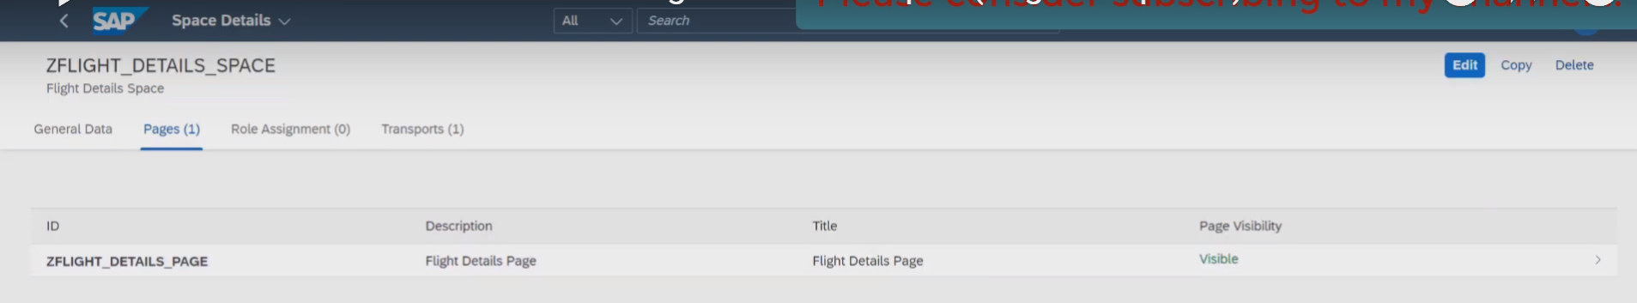

Now our page has been saved.

Next we need to assign the Role: means assign the space and page to the role.

For this navigate to sap ecc system 🡪 go to PFCG tcode

Create the role: ZFIORI_ROLE

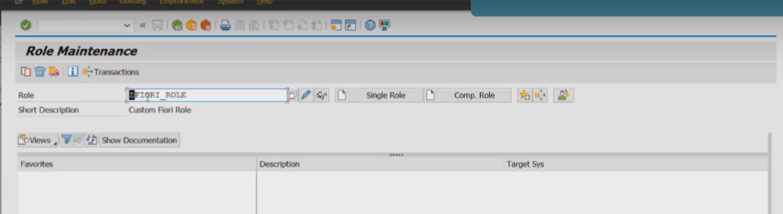

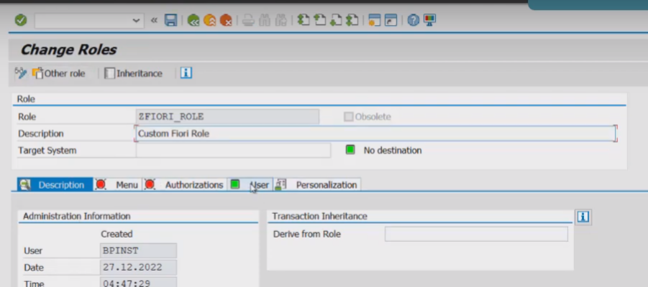

Inside the menu🡪add the Space to the role menus

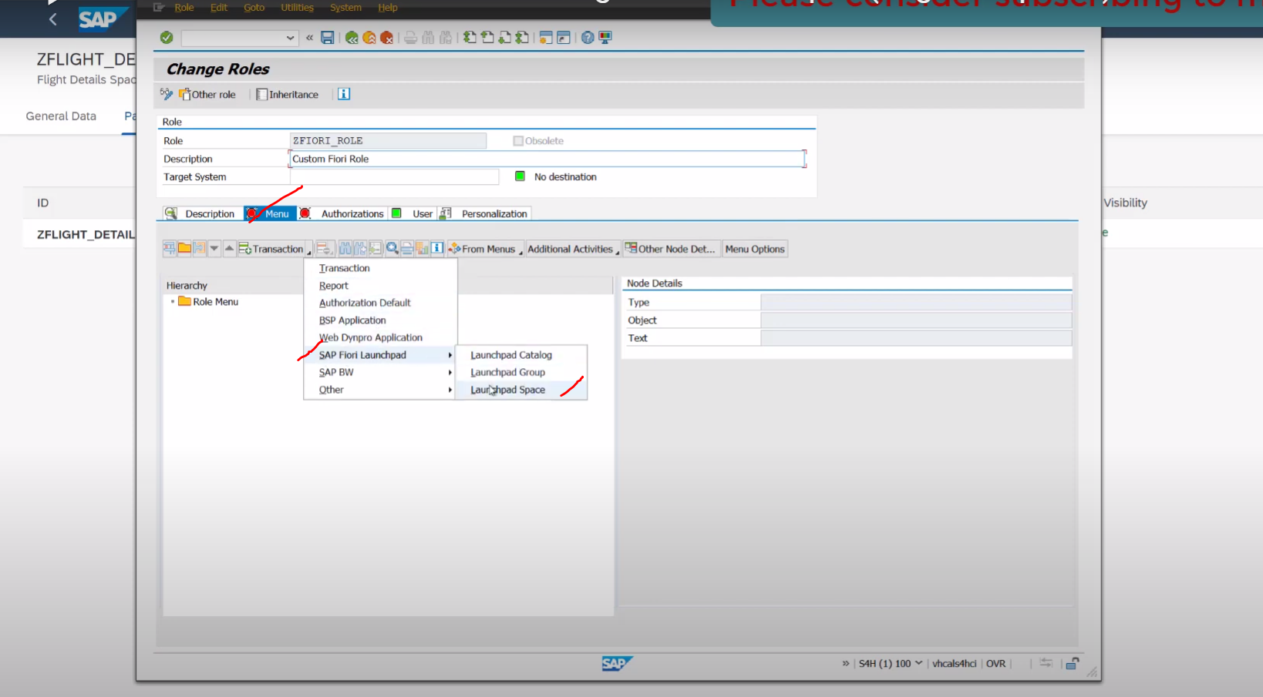

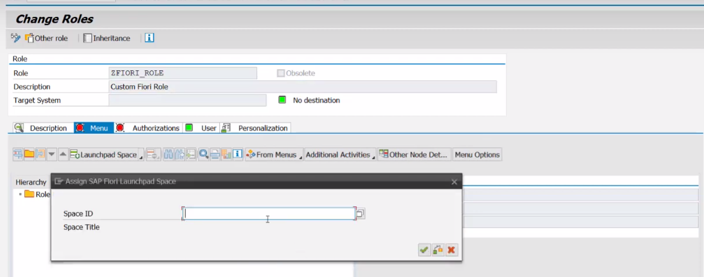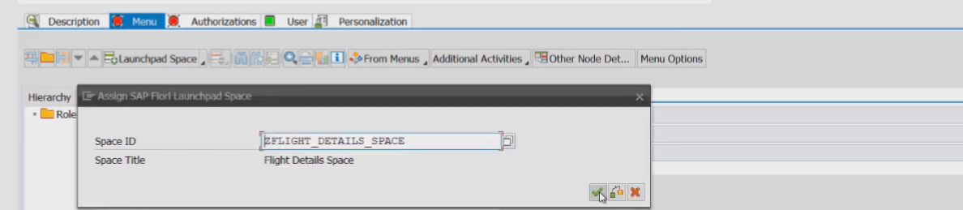

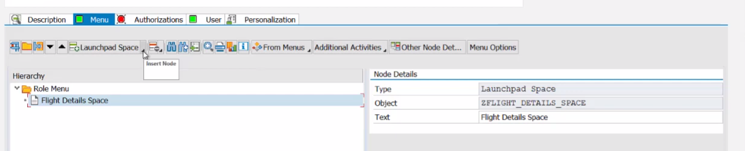

Space added here. Along with the space we need to add the catalogue to here because our report to the added to the catalogue.

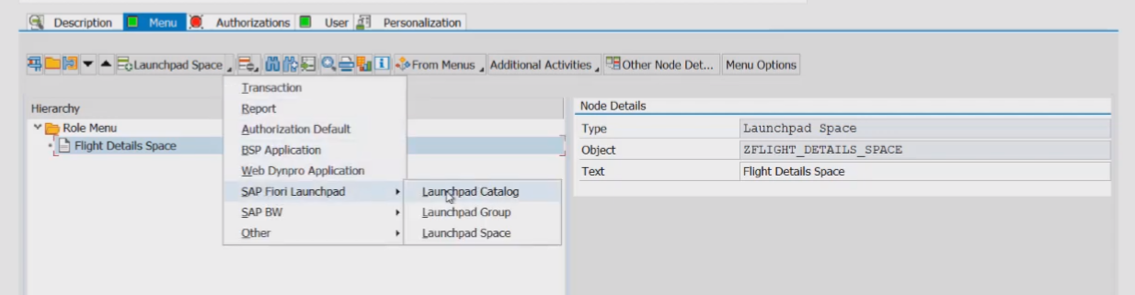

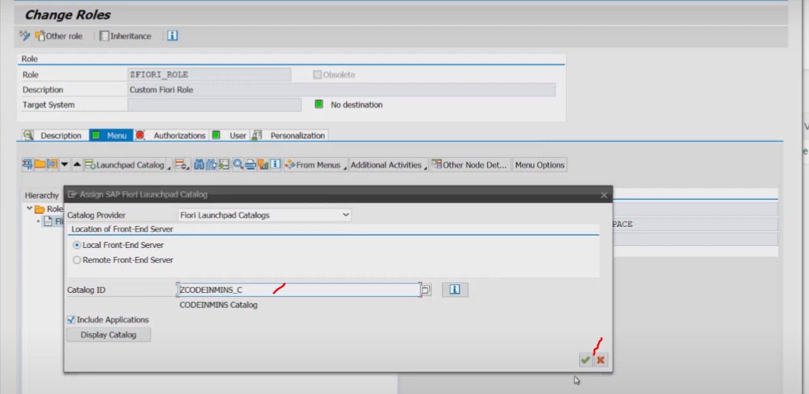

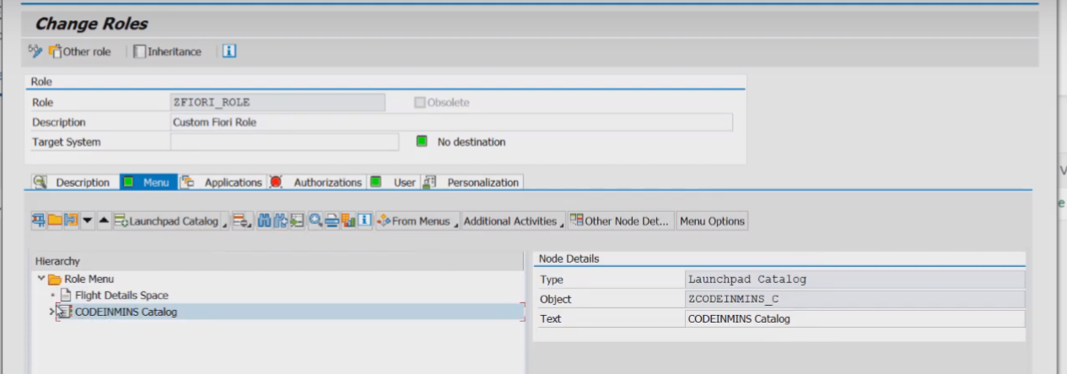

Now our catalogue and space both are added to the role 🡪 click on save

Once this is done .. we need to go back Fiori-launchpad screen

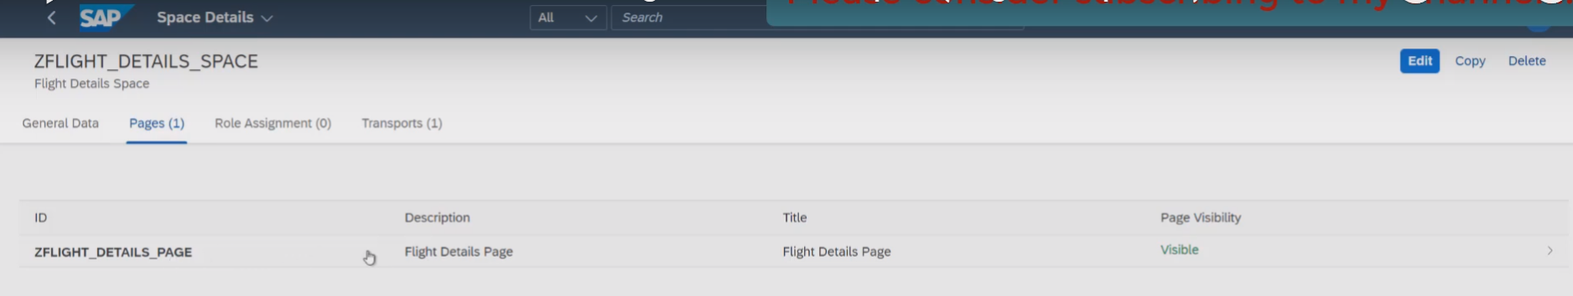

Now click on the page ZFLIGHT_DETAILS_PAGE .

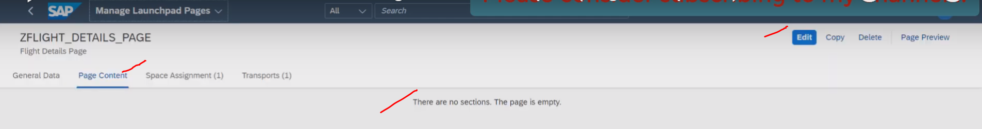

Click on EDIT

In Page Content tab: what you want to show on the page and we can able to see the report name at right side.

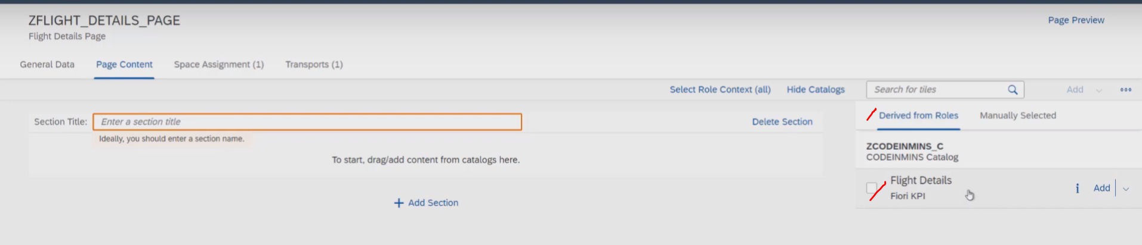

Now our report to be adding to the page content and click on to the ADD button.

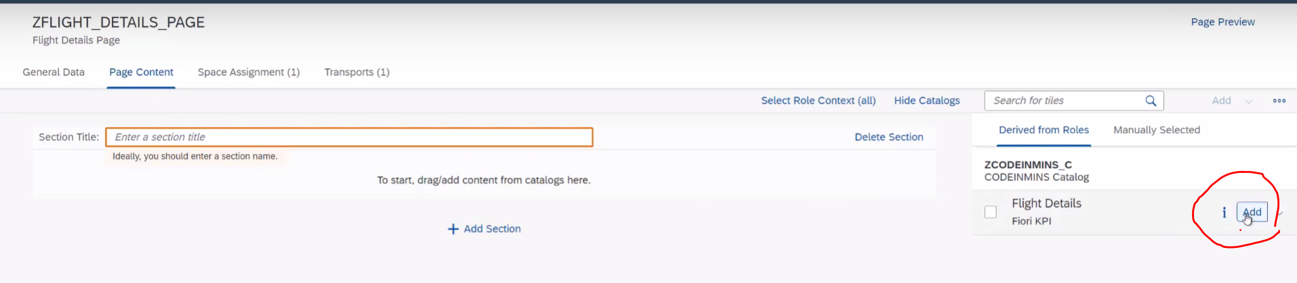

Then appears the report tile added to the Page Content.

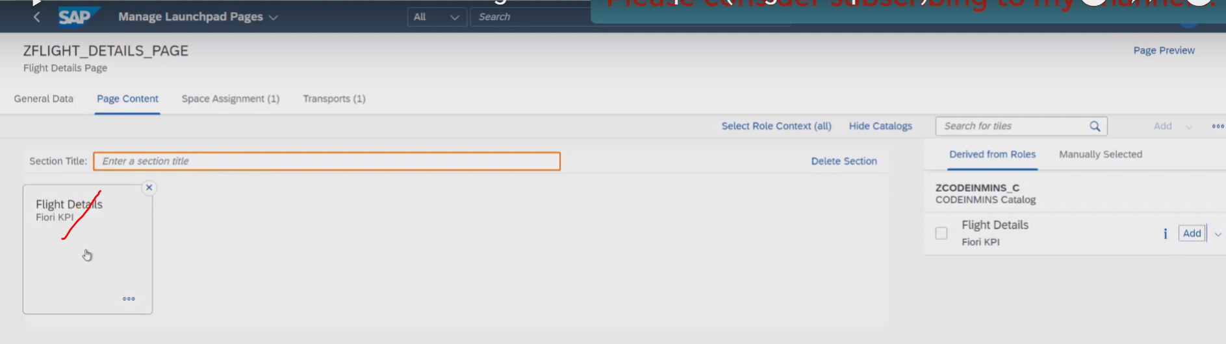

Now provide the section titles.

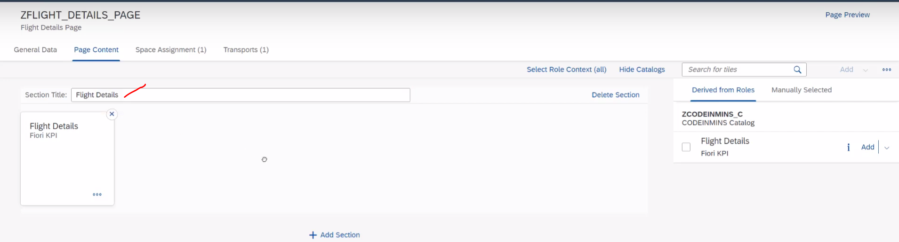

Click on SAVE button.

Now our in page content , added the report tile.

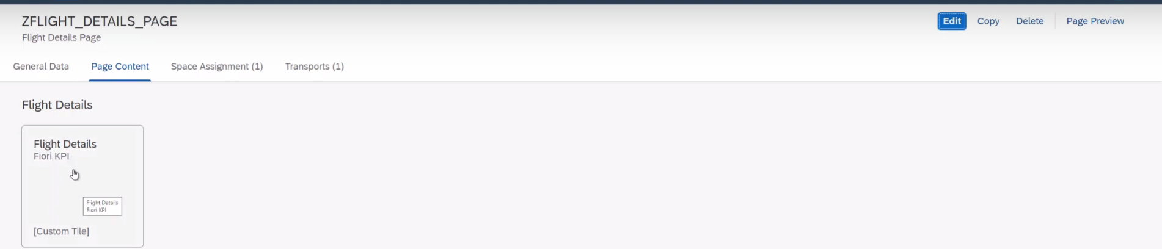

Now you want to see the page preview – click on page preview button

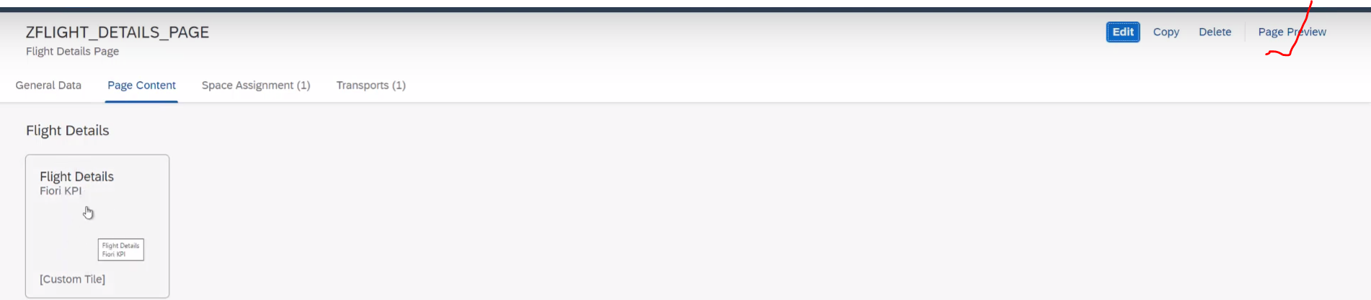

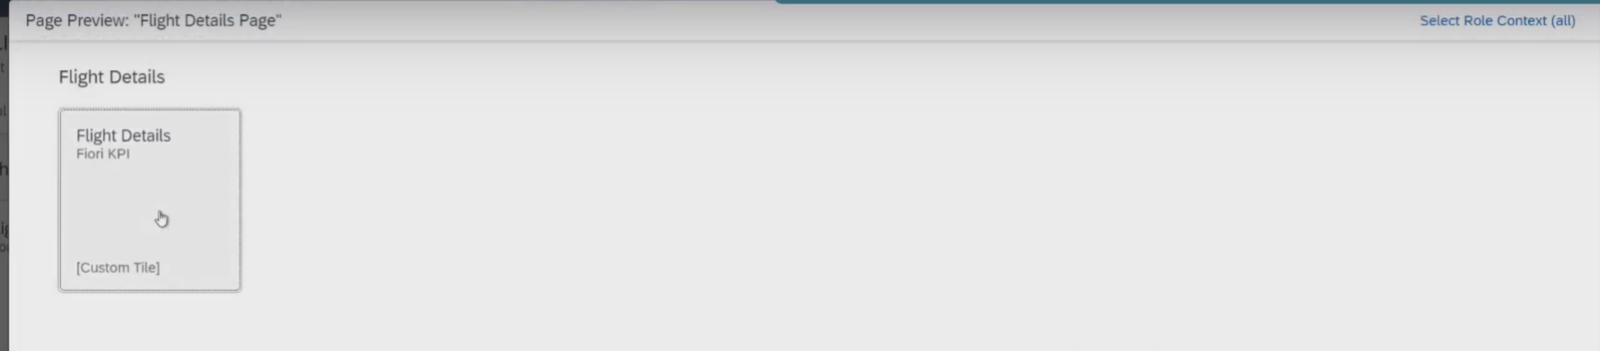

When you click on Flight Details tile 🡪 you will get all of these tile details.

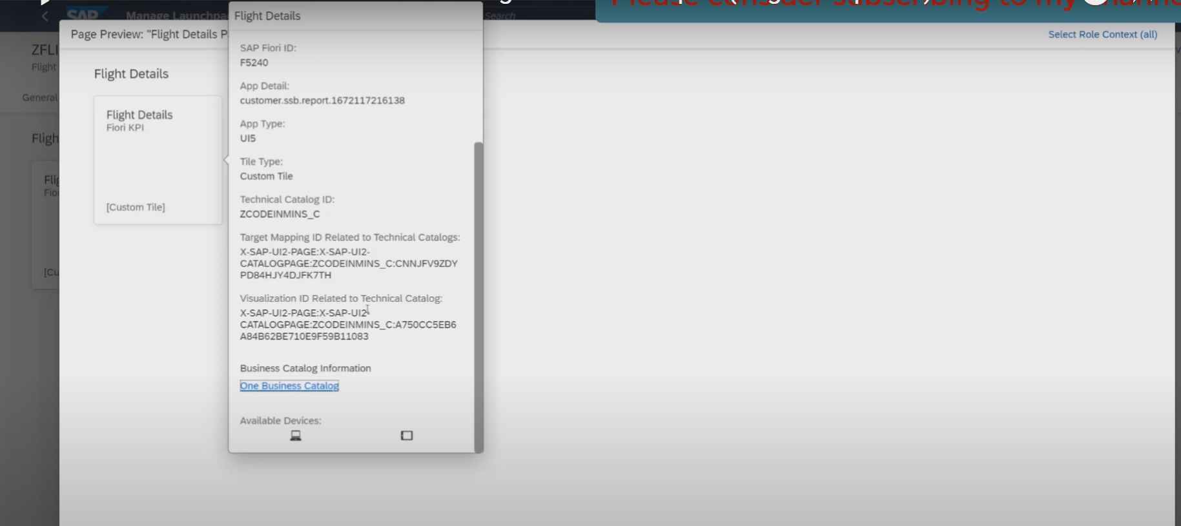

Now our report tile added to the page and we have already added the space to the role and role is assigned to the user.

Let go to the home page

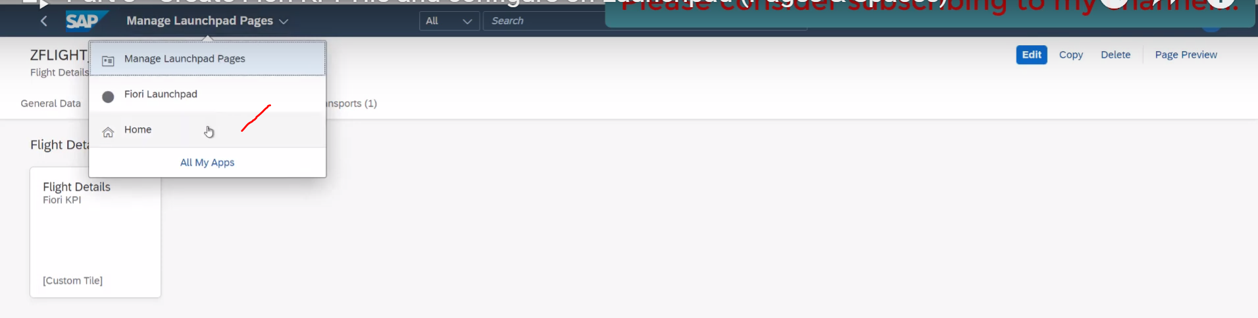

Fllight Detail Space added.

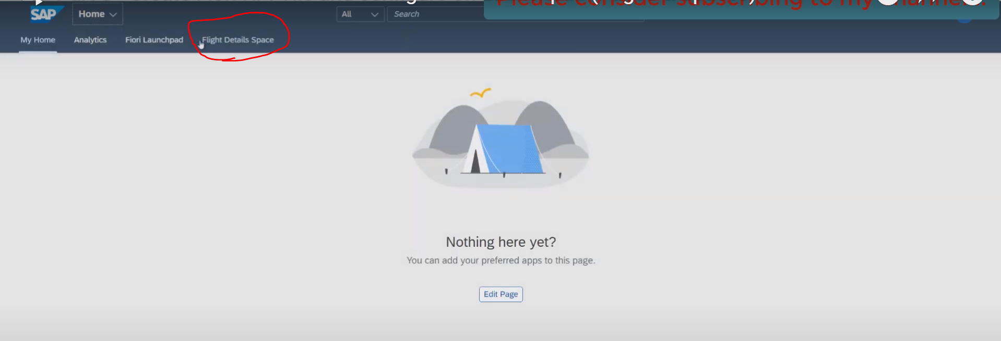

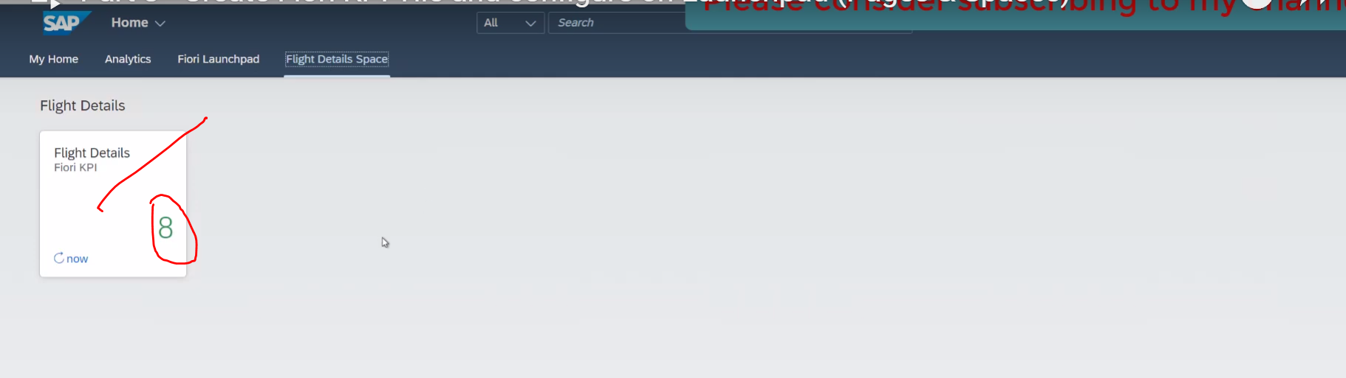

And also seeing the KPI number here- 8, which is represent the total number of flights available.

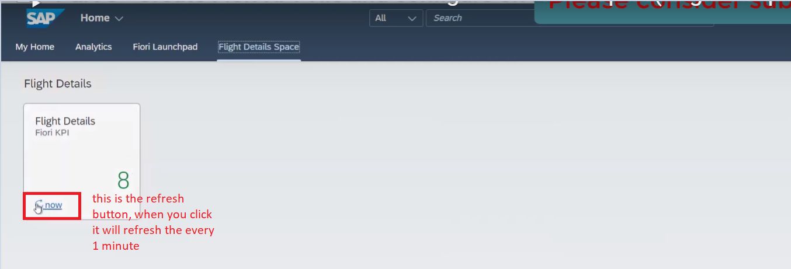when you click on the tile our report will be displayed..

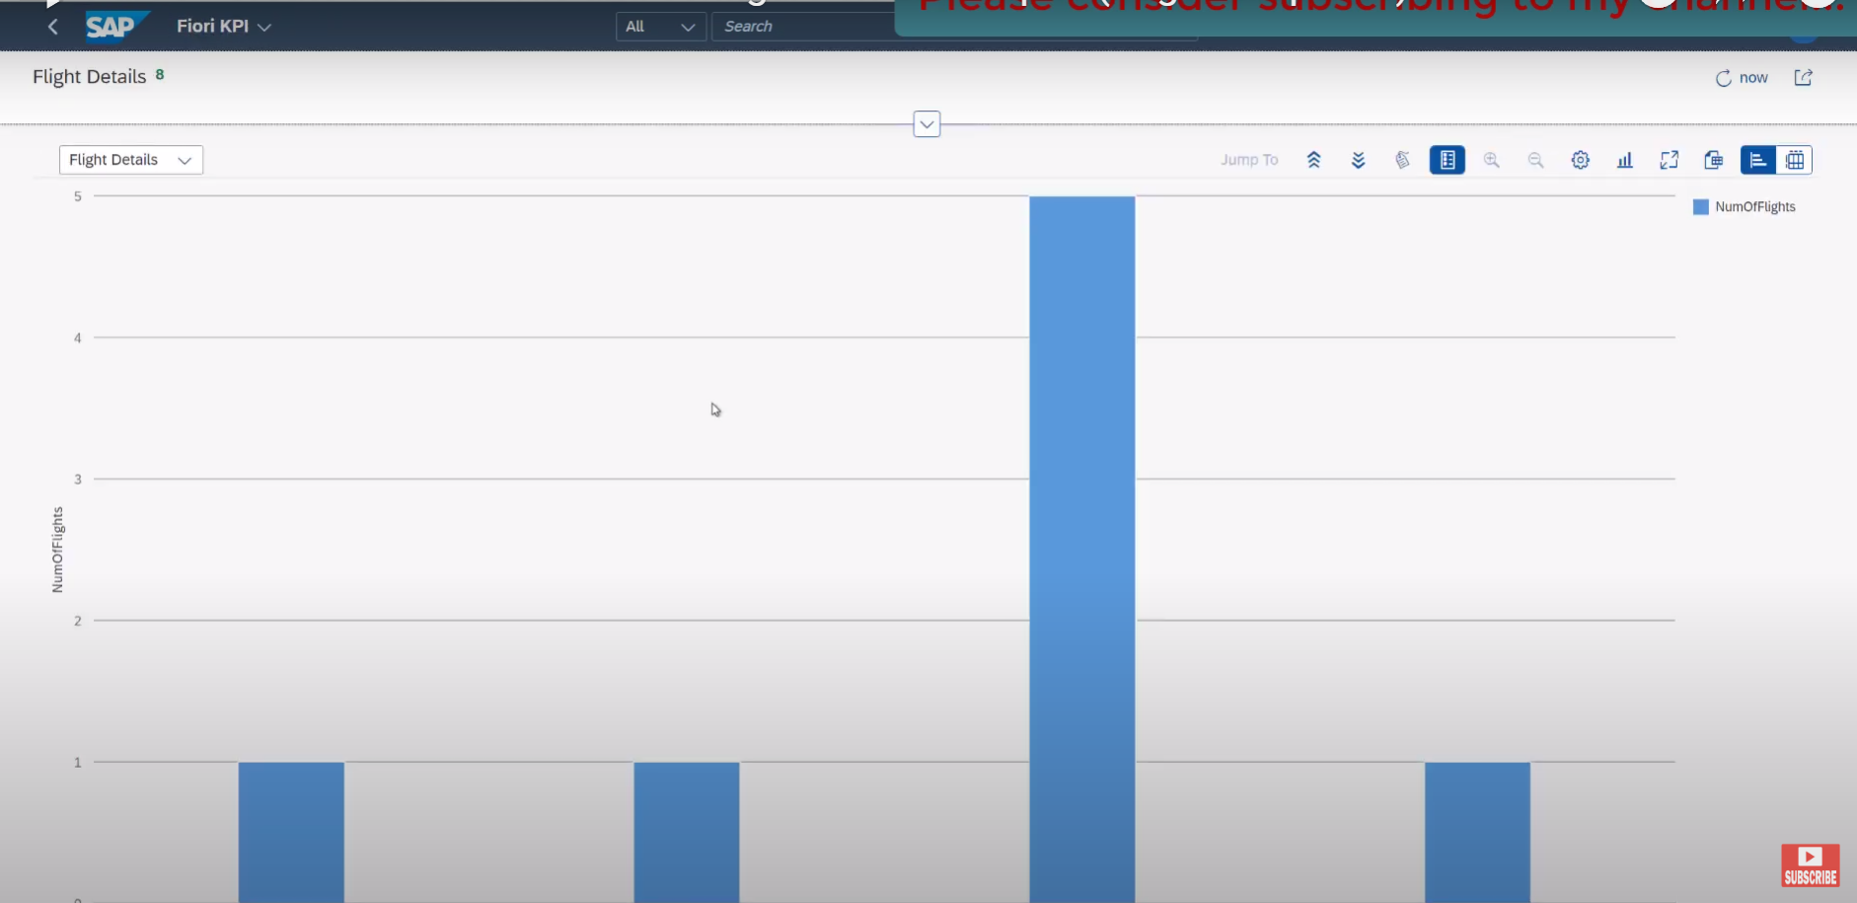

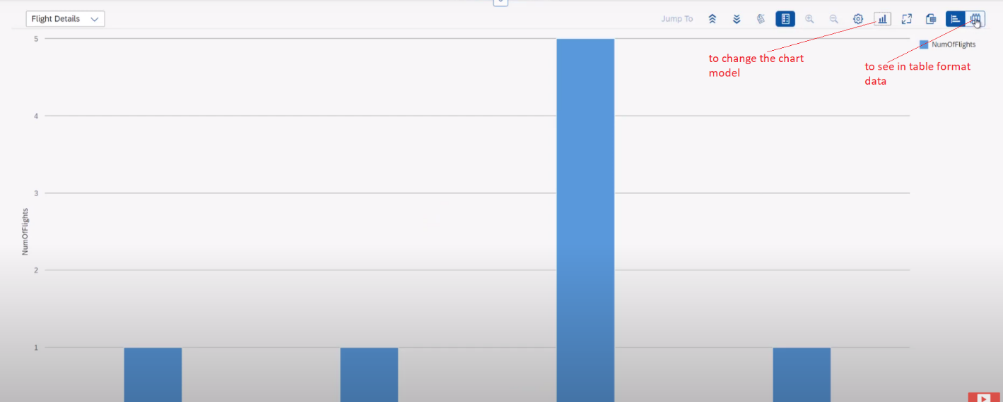

Table format:

